TABLES

Table 1. Patient demographics

Total number of patients (n) | 52
Females | 32 (61.5%)
Males | 20 (38.5%)
Age | 21-86 yrs (mean 60.5 yrs)
Jaundice
Clinically | 32 (65.3%)
Biochemically | 41 (83.7%)
Unknown | 3

Table 2: Main Specificity and Sensitivity Results

System | Diagnostic feature | Sensitivity (%) | Specificity  (%) | Positive predictive value (%) | Negative predictive value (%)
Main Papilla | Tumor present | 100 | 95.3 | 33.3 | 100
 | Stones | 33.3 | 85.4 | 14.3 | 94.6
Bile Ducts | Stones | 87 | 80 | 83.3 | 84.2
 | Dilated | 52.9 | 77.8 | 90 | 30.4
 | Strictures | 33.3 | 96.6 | 80 | 77.8
 | Occlusion | 50 | 78.9 | 11.1 | 96.8
Galbladder | Stones | 80 | 50 | 80 | 50
Pancreatic Duct | Occlusion |  | 90 |  | 94.7
 | Filling defects |  | 100 |  | 100
 | Stricture | 50 | 100 | 100 | 94.1

MRCP- AND ERCP-IMAGES TO DEMONSTRATE STONES AND STRICTURES

(Please note that images do not fit in any specific place in the manuscript-no legends are inserted in the main text)

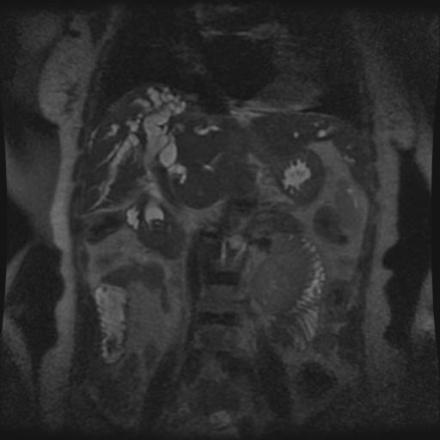

Figure 1: Coronal single-shot fast spin-echo T2 MRI demonstrating a low-intensity stone (white arrow) impacted in the common bile duct

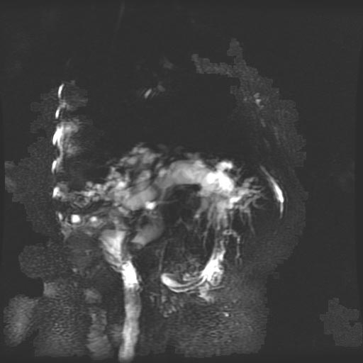
Figure 2: High resolution thick slab long TE 1100ms (rotated to RAO-position) MRCP demonstrating a stone impacted in the common bile duct (white arrow).

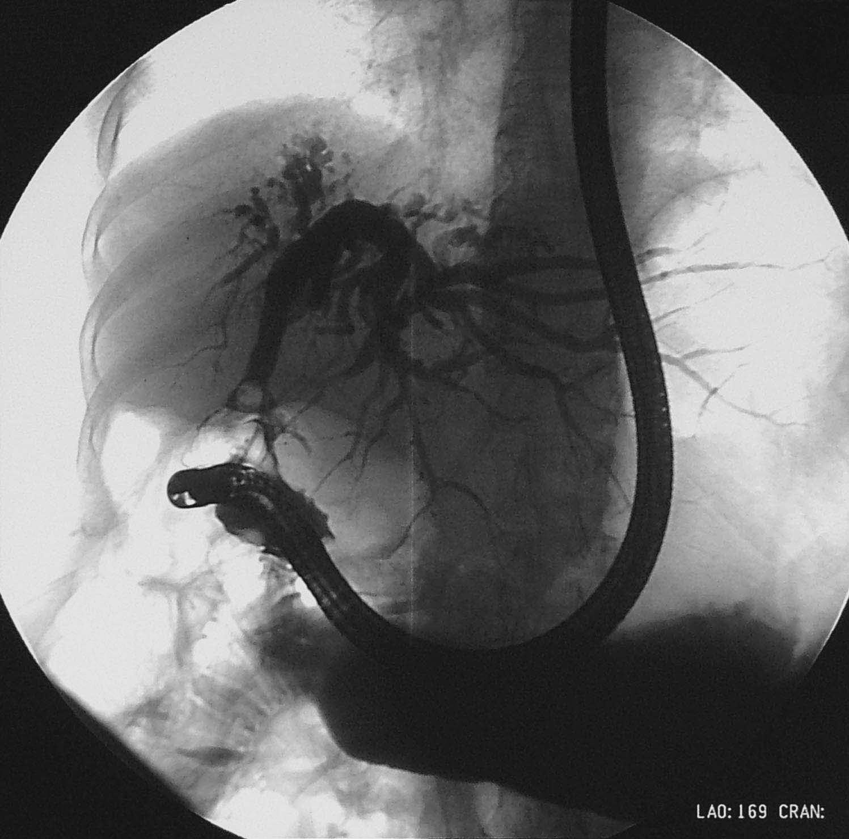
Figure 3: ERCP-Image (LAO-View) demonstrating a stone impacted in the common bile duct (white arrow) in the same patient

Figure 4: MRI’s demonstrating stenosis of the common bile (grey arrow) duct due to a tumor in the head of the pancreas (white arrow). Figure A: Axial SSFSE T2;
Figure B: coronal SSFSE T2; Figure C: high resolution thick slab long TE 1100ms

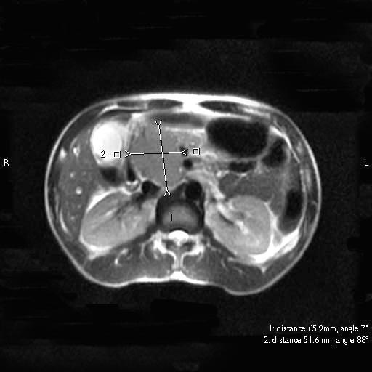
4A

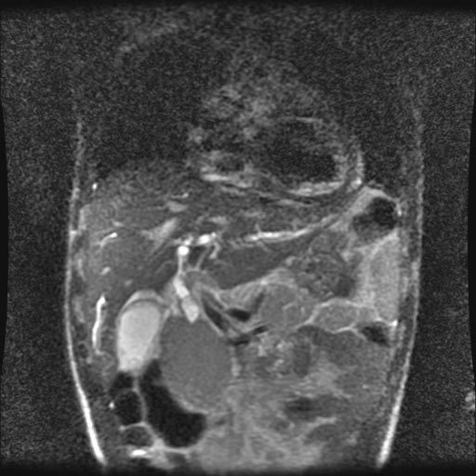
4B

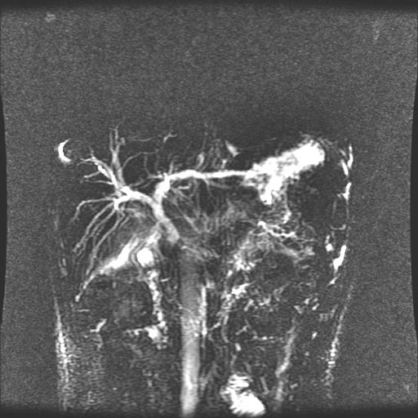
4C
Figure 5: ERCP (LAO-View) demonstrating stenosis (white arrow) of the common bile duct due to a tumor in the head of the pancreas. Figure 5A: Before stenting, Figure 5B: after inserting a stent

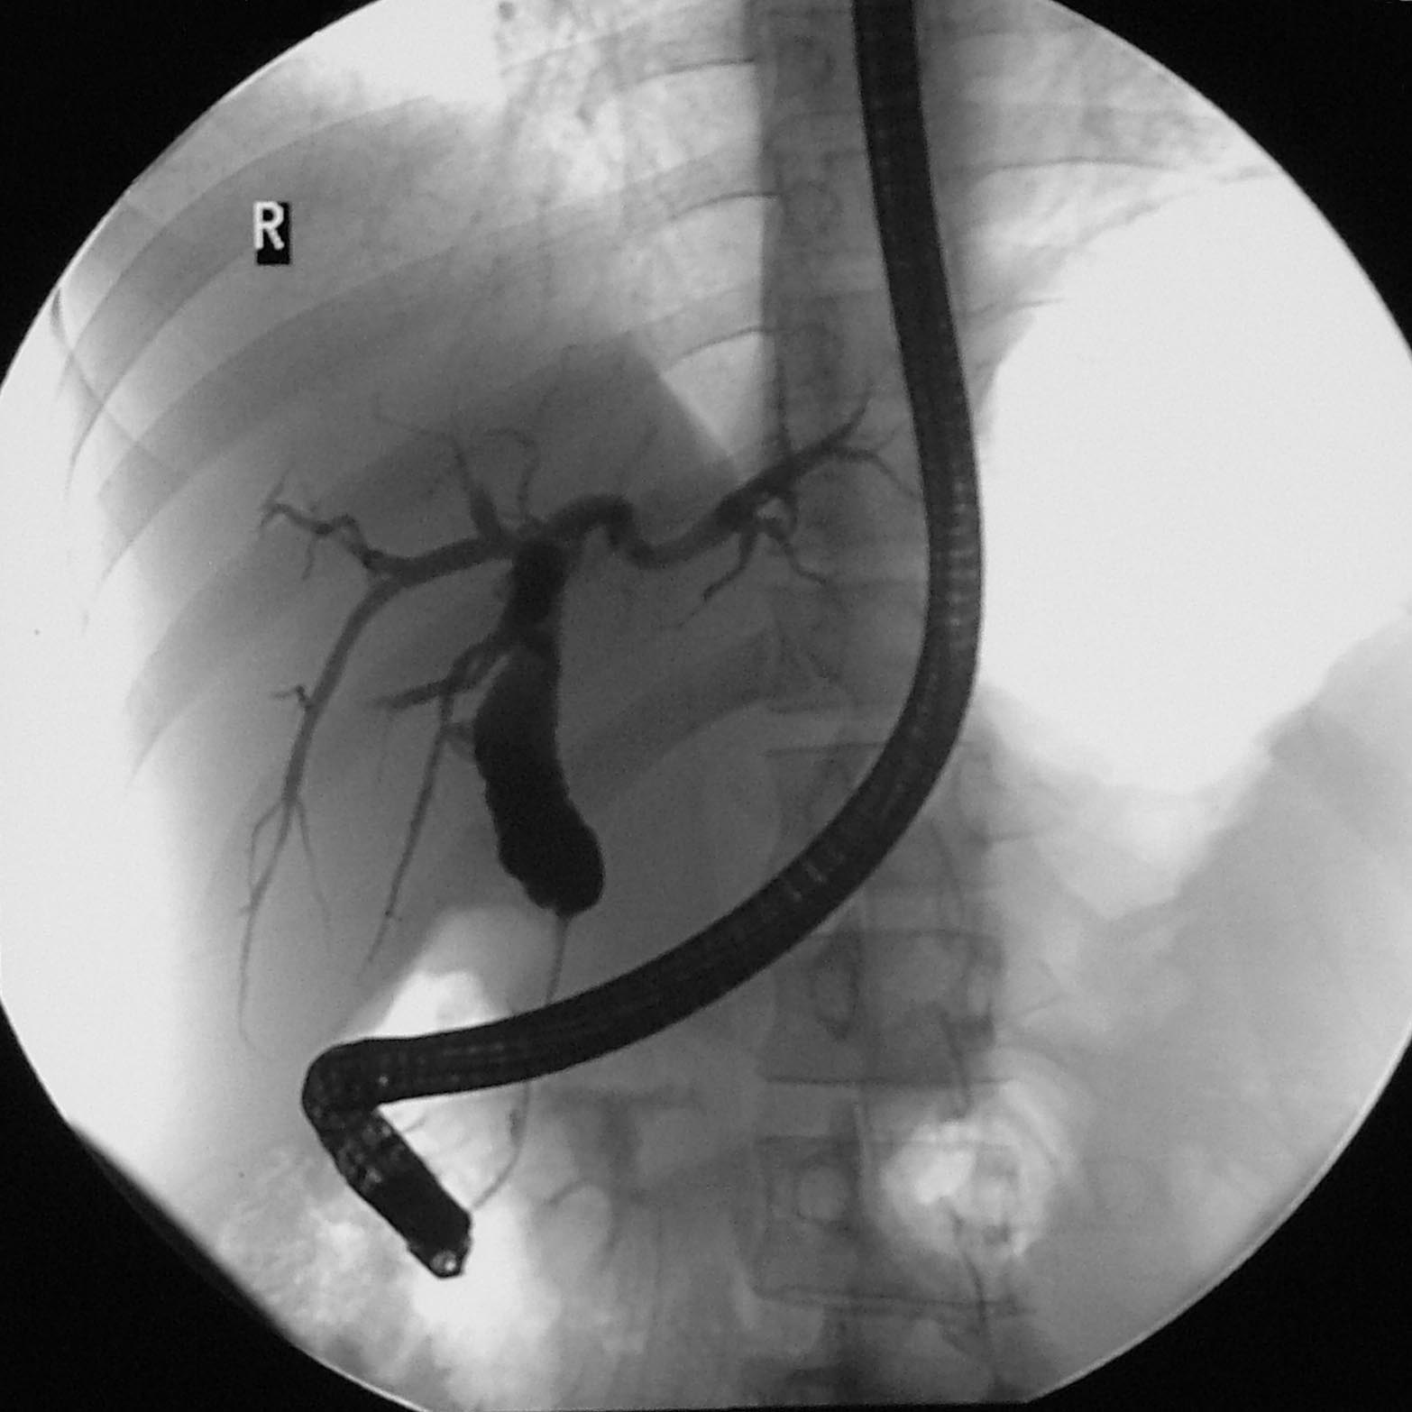
5A

B
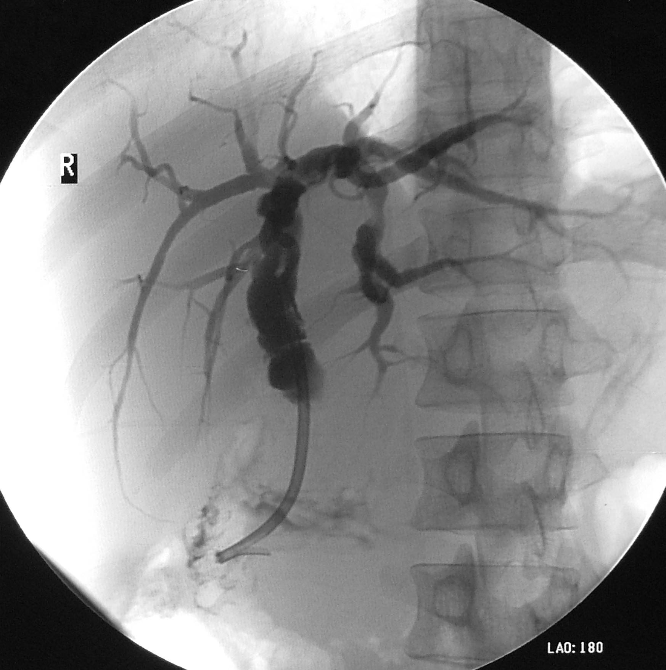
5B
Stent

