Figure 7a:
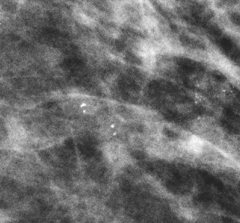
Mammogram

Figure 7b:

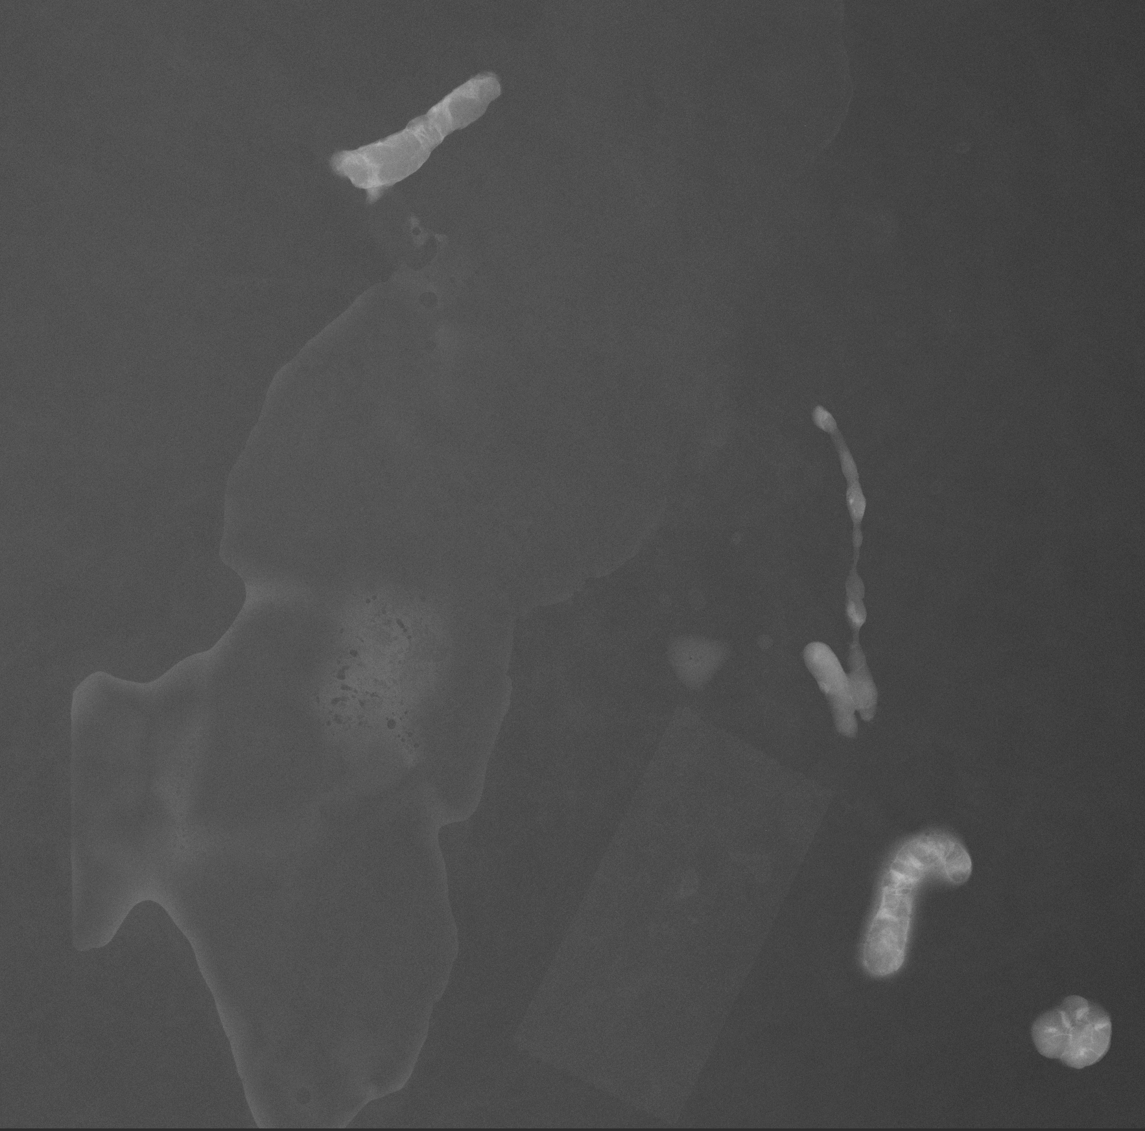

Patient 7: Clusters of heterogeneous, punctuate calcifications (Fig 7a)– calcification pattern is benign. Radiograph of specimens (Fig 7b) demonstrates calcifications have been removed in biopsy.

