Figure 1
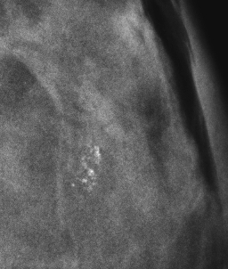

Figure 2

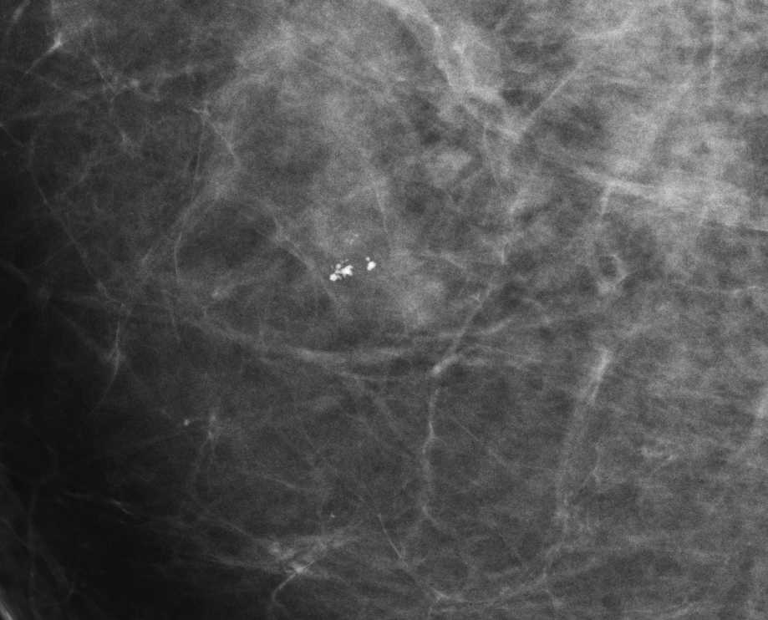

Figure 3

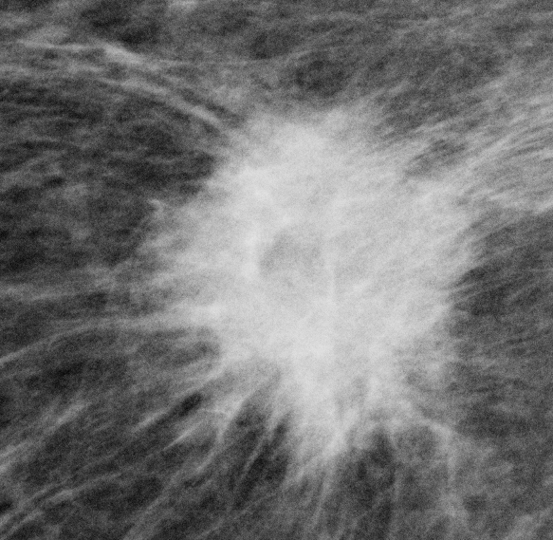

Figure 4:
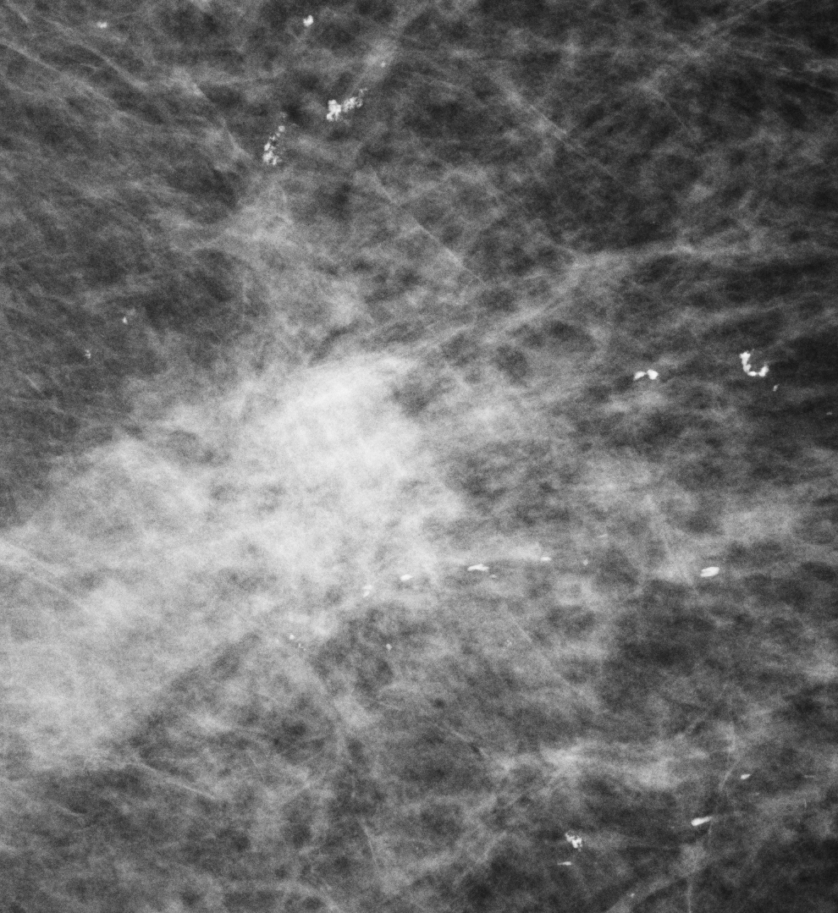

Figure 5

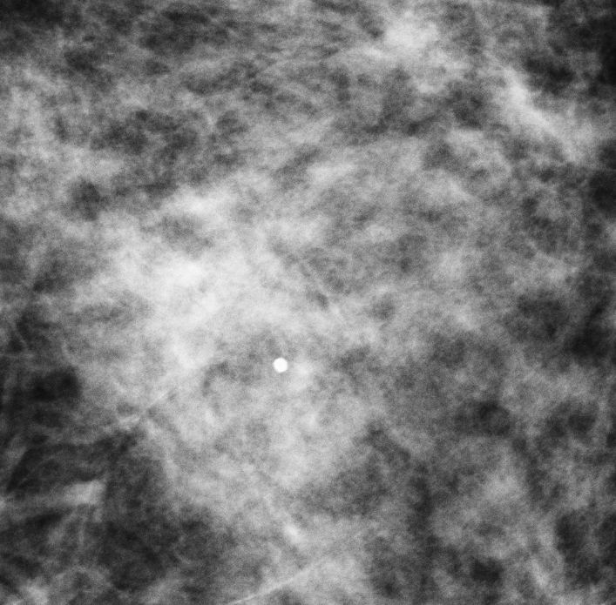

Figure 6
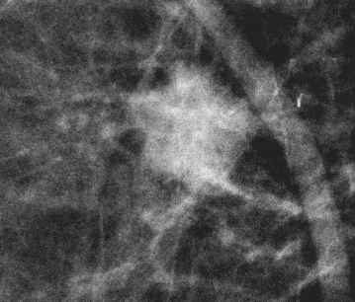

Figure 7a:
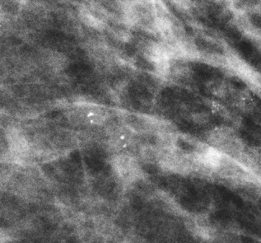
Mammogram

Figure 7b:

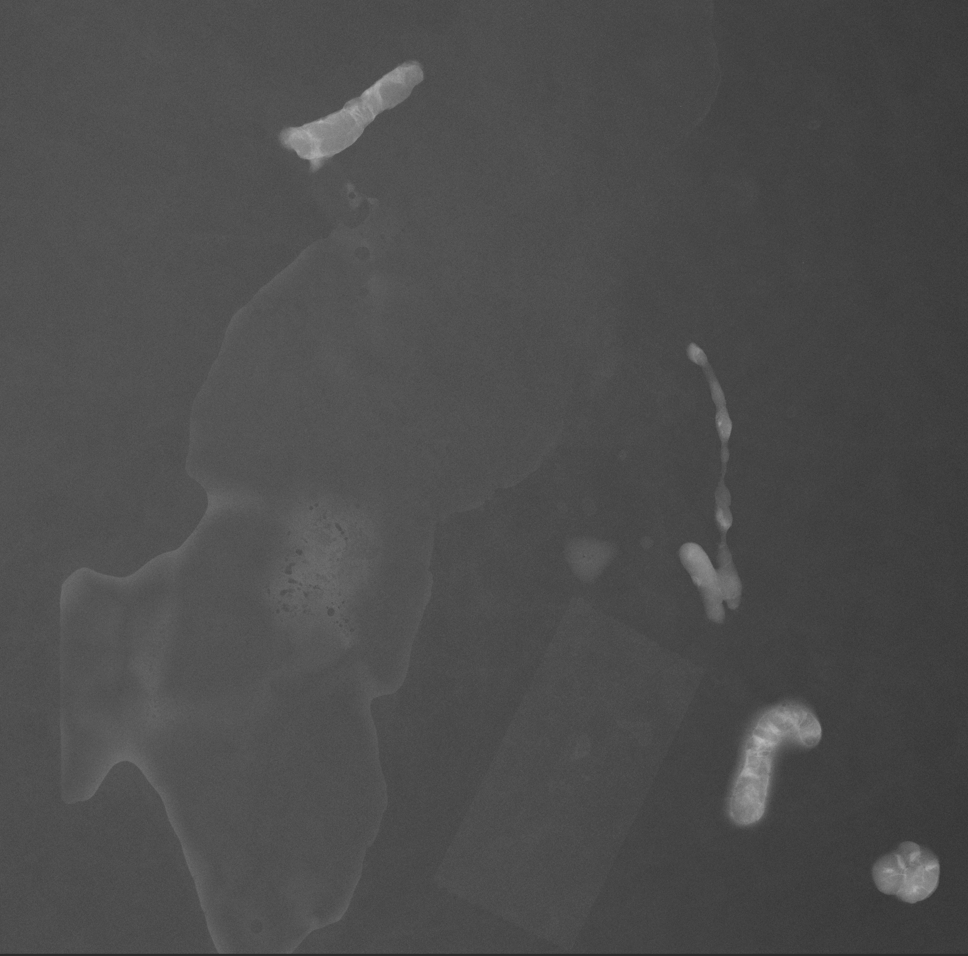

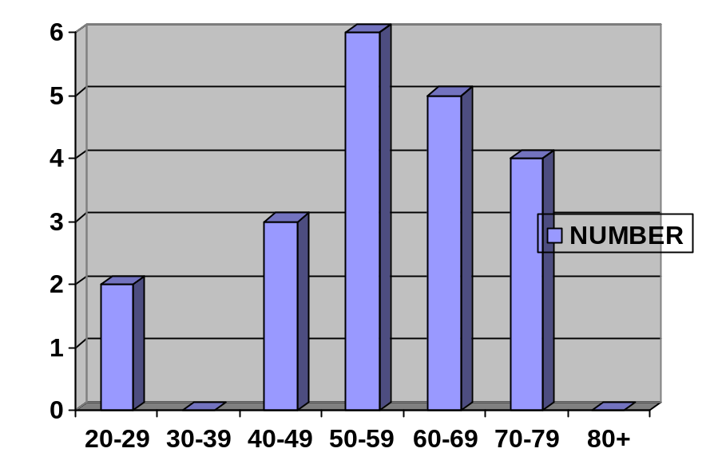

Figure 1: Graphic representation of age distribution

Table 1: Histology of benign disease.
 | NUMBER
EPITHELIAL HYPERPLASIA | 1
CHRONIC INFECTION | 2
NO MALIGNANCY | 3
FIBROADENOSIS | 2
INTRADUCTAL PAPILLOMA | 1
RADIAL SCAR | 1

Table 2: Clinical and other relevant history in patients with ductal carcinoma.
AGE | 20’s = 2, 40’s =1, 50’s = 2, 60’s = 2, 70’s =4
NO CHILDREN | 1
NEVER BREAST FED | 1
POSITIVE FAMILY HISTORY | 5
POST MENOPAUSAL | 5
BREAST MASS | 8
DUCTAL CARCINOMA GRADES: | DCIS: 7 ( 1= COMEDO TYPE DCIS)  INFILTRATING DCIS: 4

Table 3: Compares the Calcification Patterns with the final histology

MAMMOGRAPHIC DESCRIPTION | HISTOLOGICAL RESULT
1. Cluster, pleomorphic and amorphic – calcification pattern is malignant | Fibrosis  Chronic Infection
2.Pleomorphic, well circumscribed – calcification pattern is benign | DCIS
3. Heterogeneous (with spiculated mass) – calcification pattern is malignant | DCIS
4. Scattered punctuate, linear and amorphous (with mass) – calcification pattern is benign | DCIS
5. Single round calcification (with mass) – calcification pattern is benign | Acute on chronic infection
6. Clumped, dense calcification pattern (with mass) – calcification pattern is benign | Infiltrating DC
7. Clusters of heterogeneous, punctuate calcifications – calcification pattern is benign | Ductal Ectasia
8. Amorphic calcifications in ill defined lesion – calcification pattern is malignant | No malignancy
9. Linear and punctuate calcifications in area of architectural distortion – calcification pattern is malignant | No malignancy
10. Clusters of linear and punctuate calcifications ( with speculated mass) – calcification pattern is malignant | DCIS
11.Dense, clumped pleomorphic calcifications (with mass) – calcification pattern is malignant | Infiltrating DC
12.Rod shaped, scattered calcifications (with skin retraction) – calcification pattern is benign | Fibroadenosis
13. 13A – clustered, pleomorphic punctuate calcifications (with mass) – calcification pattern is malignant  13B – Large dystrophic calc, punctate calcifications dispersed (with mass) – calcification pattern benign  13C – Dense clustered calcifications (with mass) calcification pattern benign | 13A – Invasive DC  13B – DCIS  13C – Invasive DC
14 Segmental, pleomorphic calcifications – calcification pattern is malignant | DCIS – comedo type
15 Scattered calcifications (with architectural distortion) – calcification pattern benign | Fibroadenosis
16 Diffuse punctate calcifications (with mass) – calcification pattern malignant | Invasive ductal carcinoma
17 Segmental clustered pleomorphic and punctate calcifications (no mass) – calcification pattern malignant | Invasive ductal carcinoma – comedo type.
18 Scattered punctate calcifications (with mass) – calcification pattern benign | DCIS
19 Dense clusters of amorphic calcifications (with mass) – calcification pattern malignant | Radial scar with focal MC
20 Few clumped amorphic calcifications (architectural distortion, no masses in I and II) – calcification pattern malignant | I = No abnormality detected  II = No abnormalities detected

