Images For Sirenomelia Article
Figure 1
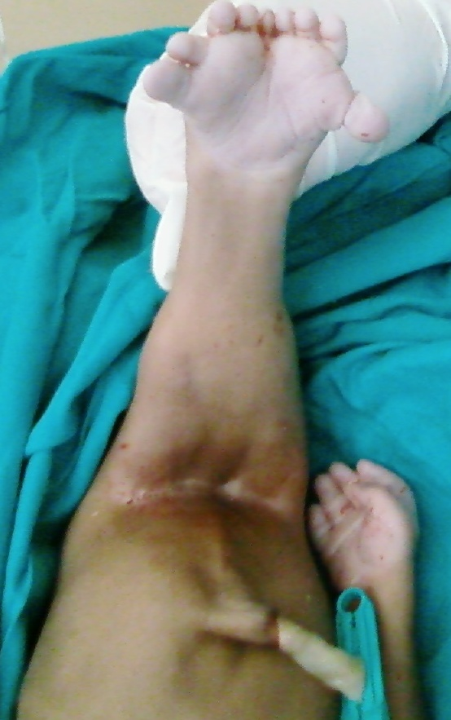

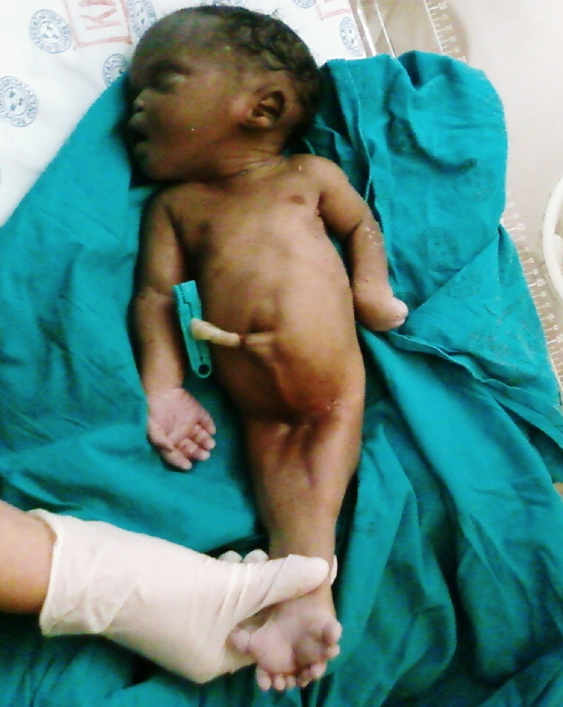

Photographs of a siren with fused lower limbs.

Figure 2

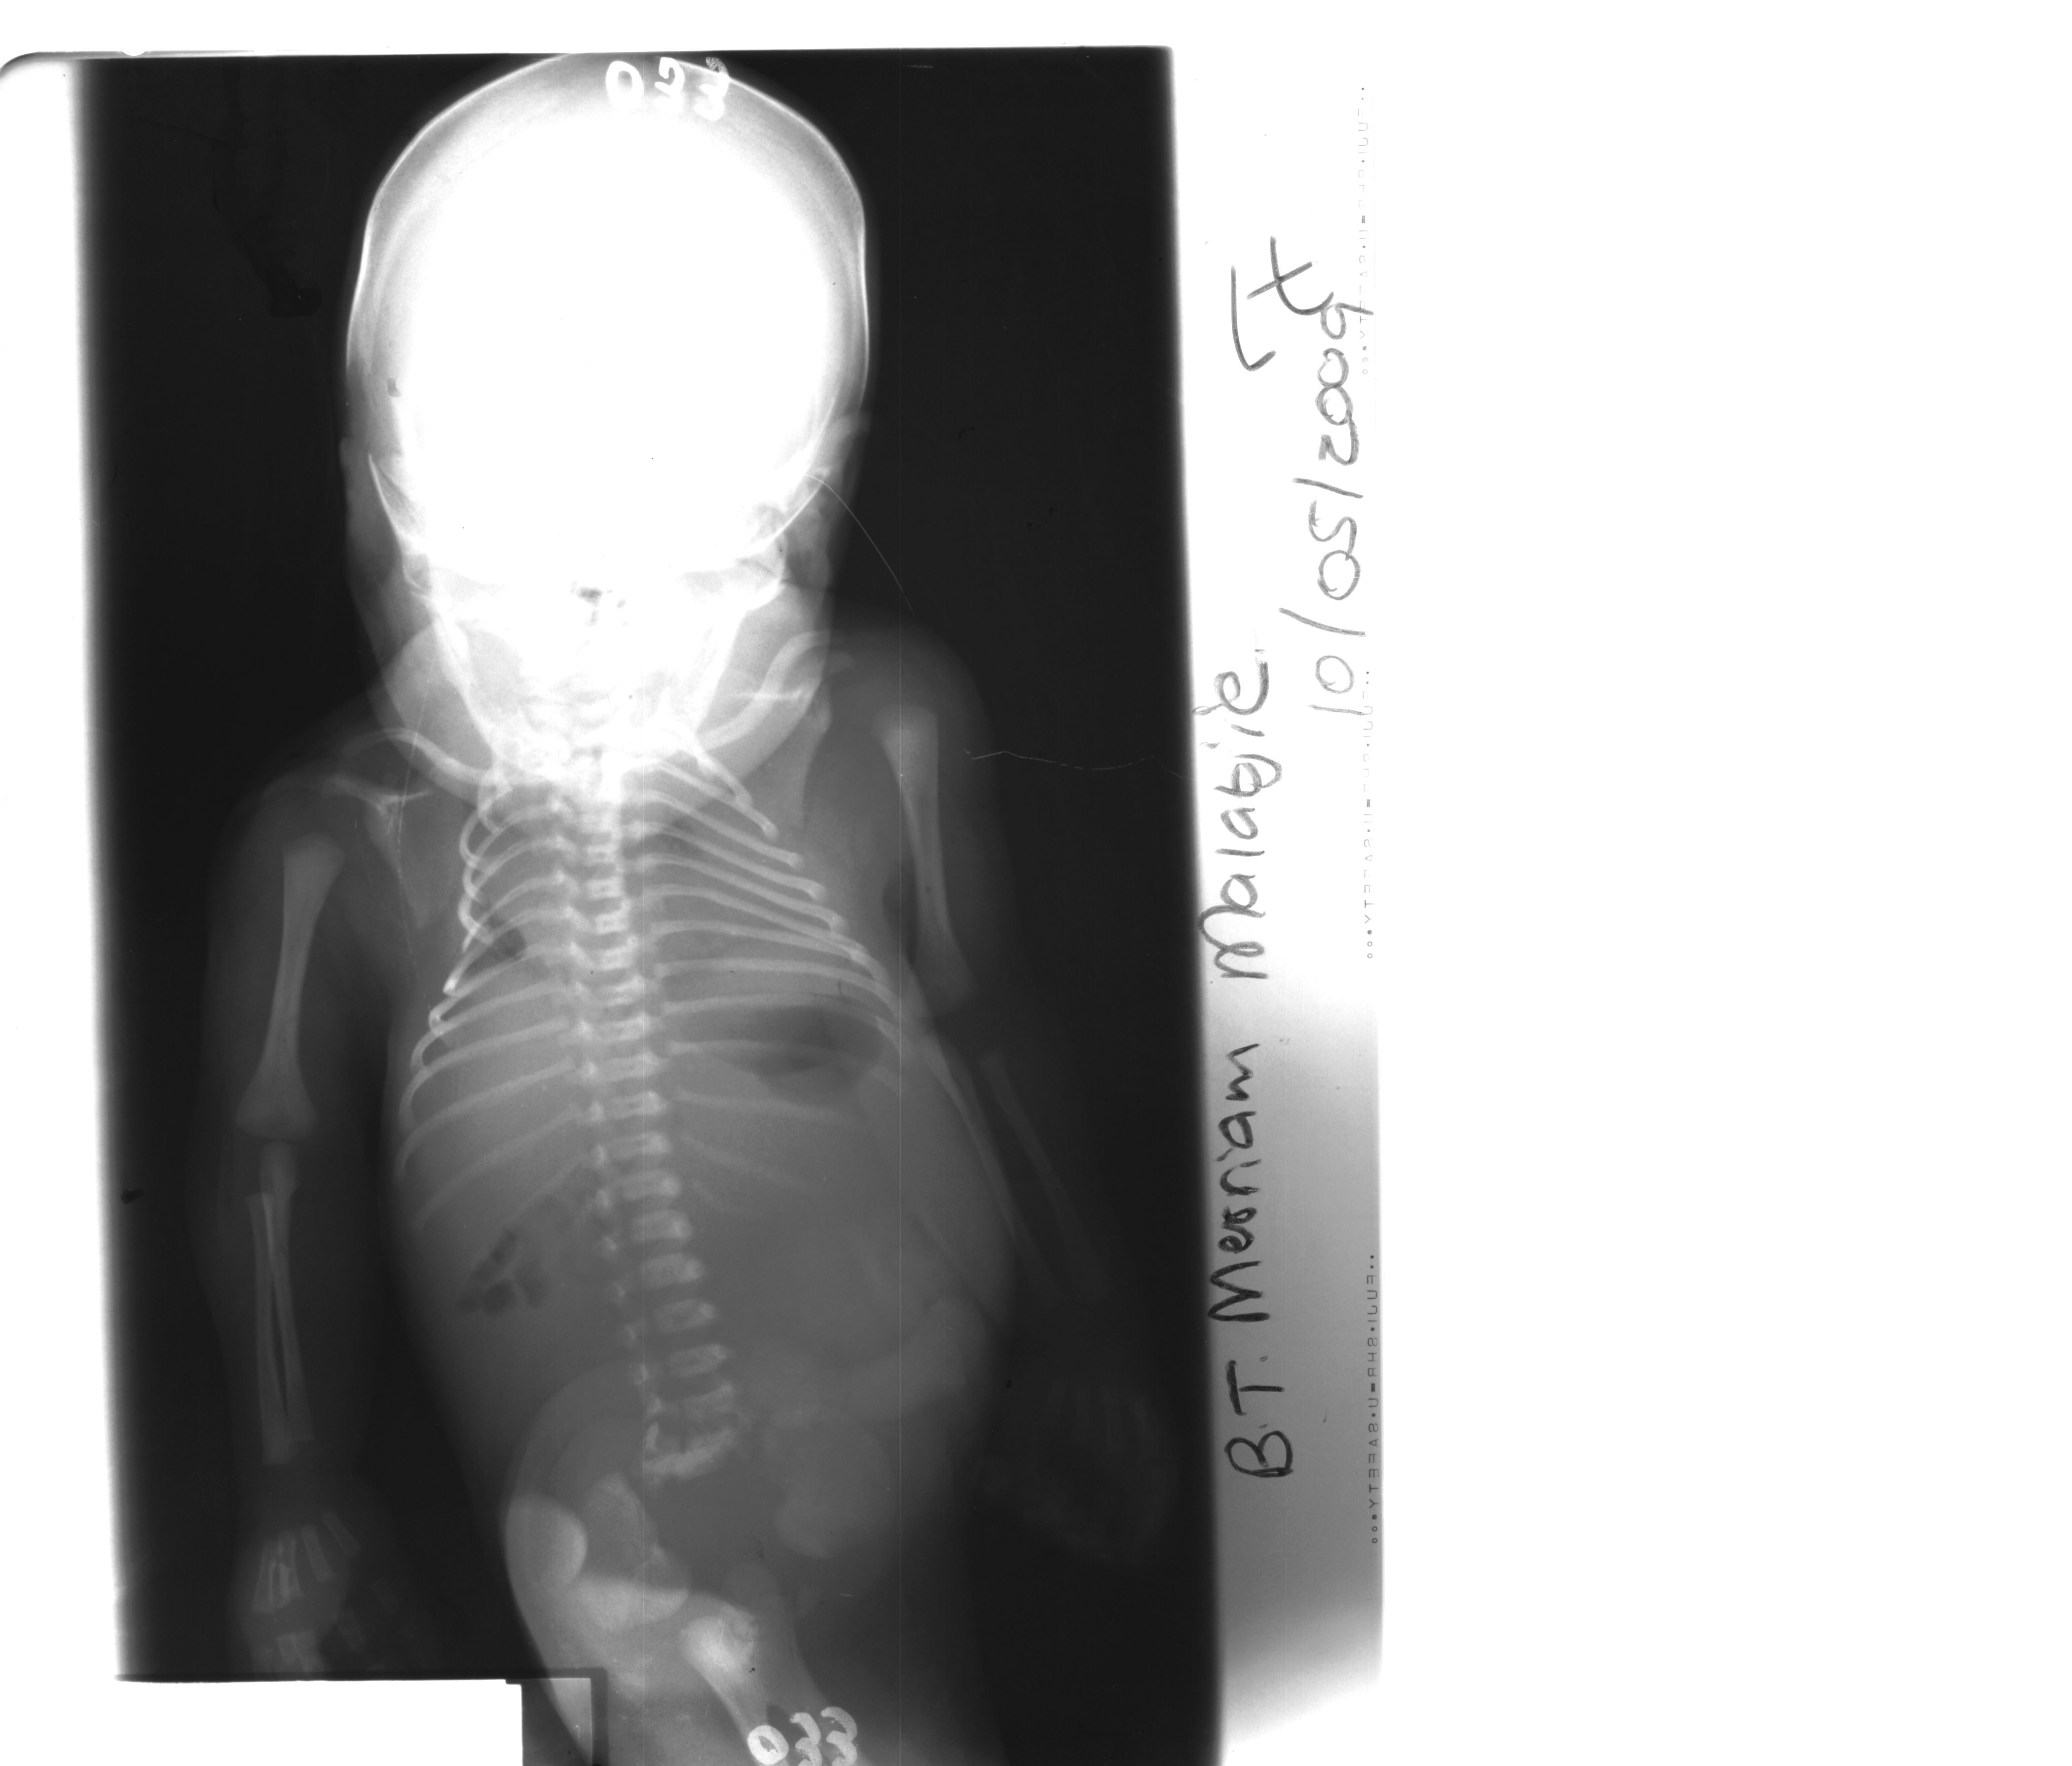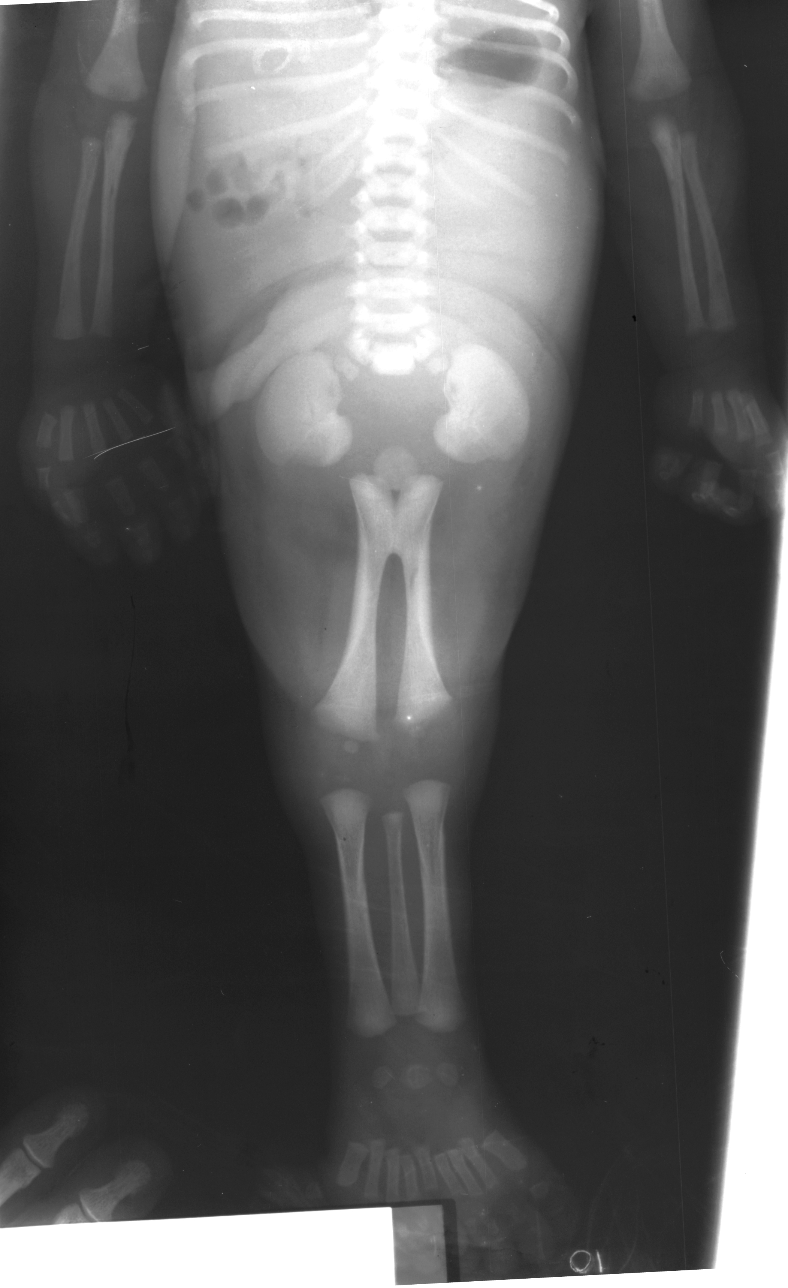

Figure 2:
Antero-posterior radiographs of the upper chest and abdomen and the lower extremities shows complete fusion of the lower limbs and feet with two femurs, two tibiae and a single fibula. There is fusion of both feet. This fits in partially with symelia limbus. Note also the dysgenesis of the pubic and ischial bones and agenesis of the sacrum.

