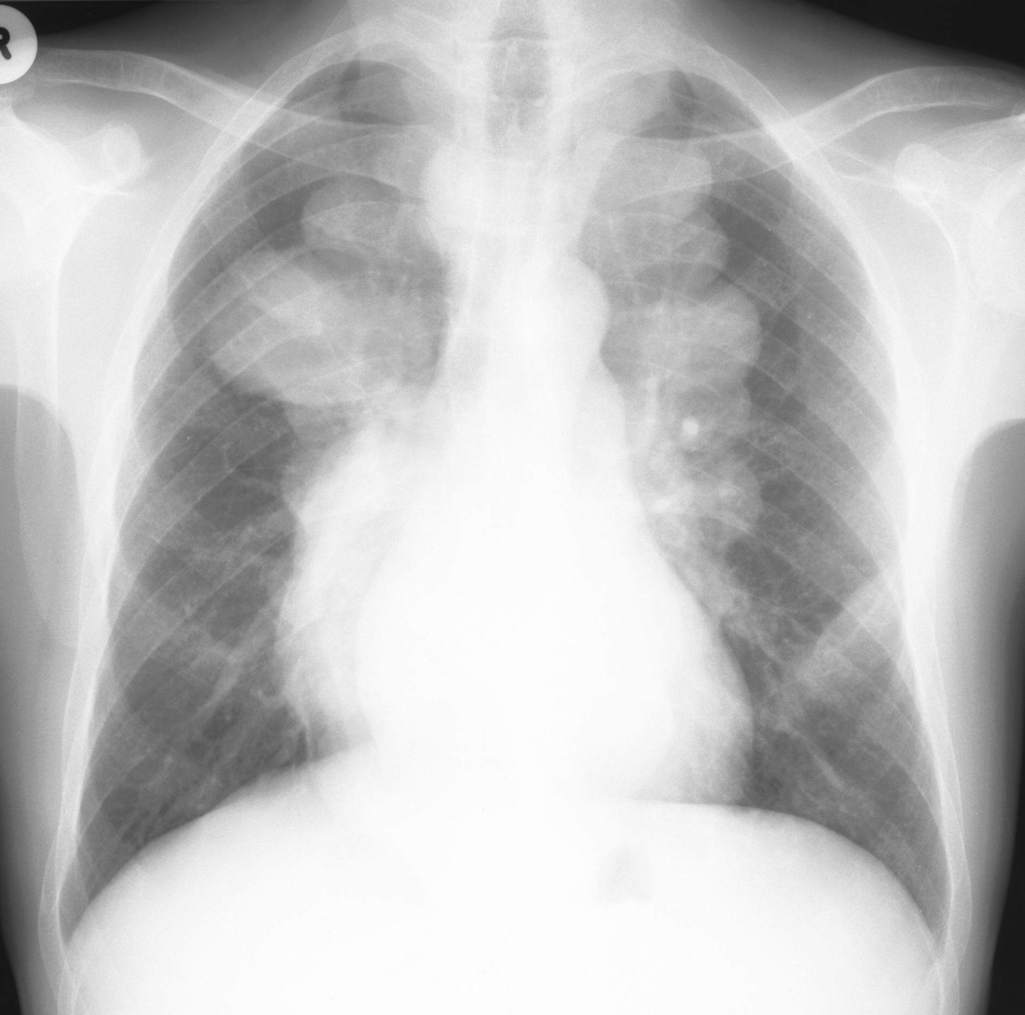

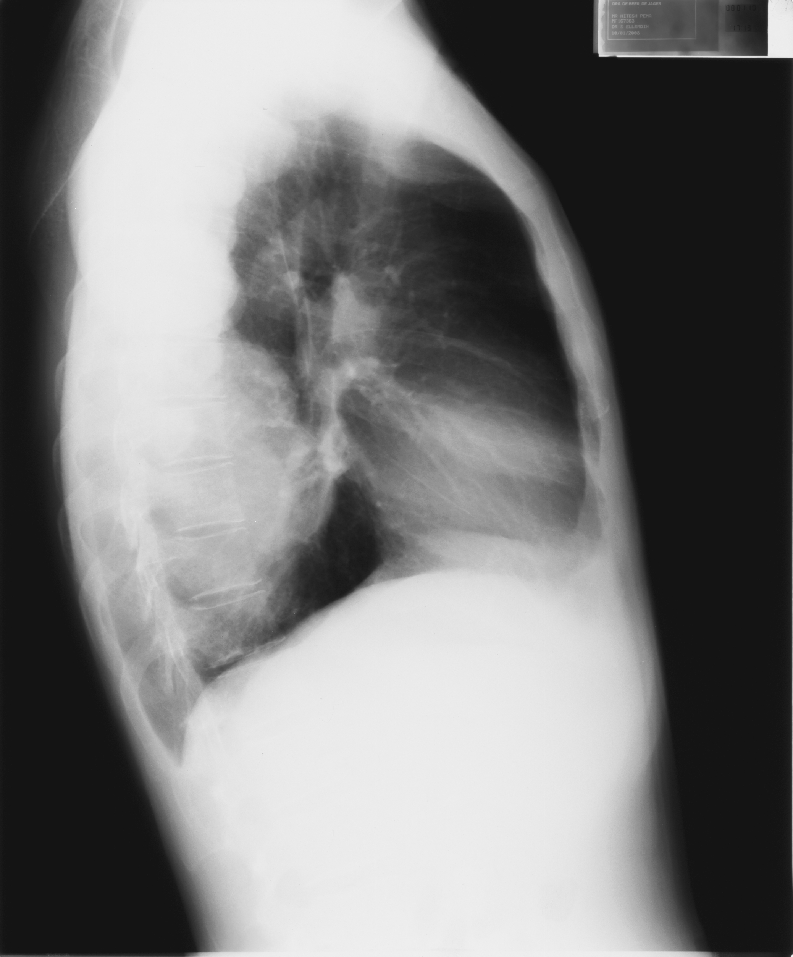

Figure 1: Frontal and lateral radiograph of the chest shows lobulated soft tissue posterior mediastinal masses and medullary expansion of the ribs and clavicles with thinning of the cortices.

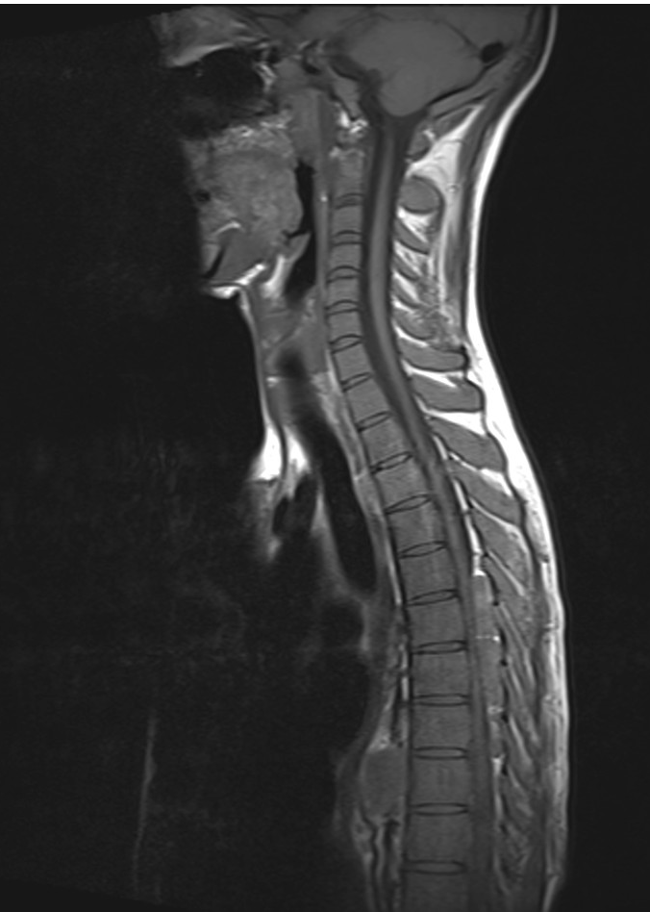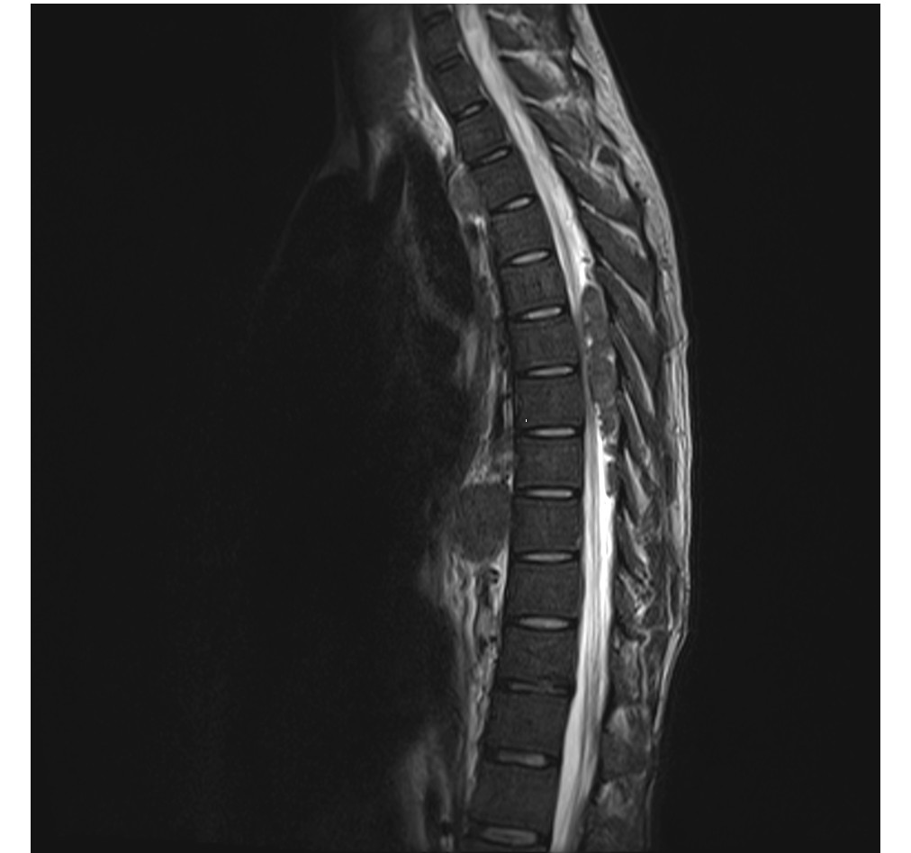

Figure 2:
Sagittal T1 and T 2 weighted sequences demonstrate extradural lobulated soft tissue masses which cause compression of the spinal cord at levels T5 to T8. These masses are iso-intense to the marrow within the adjacent vertebral bodies. There is enlargement of the central canal distal to the region of compression. There is also a mass anterior to T9 vertebral body.

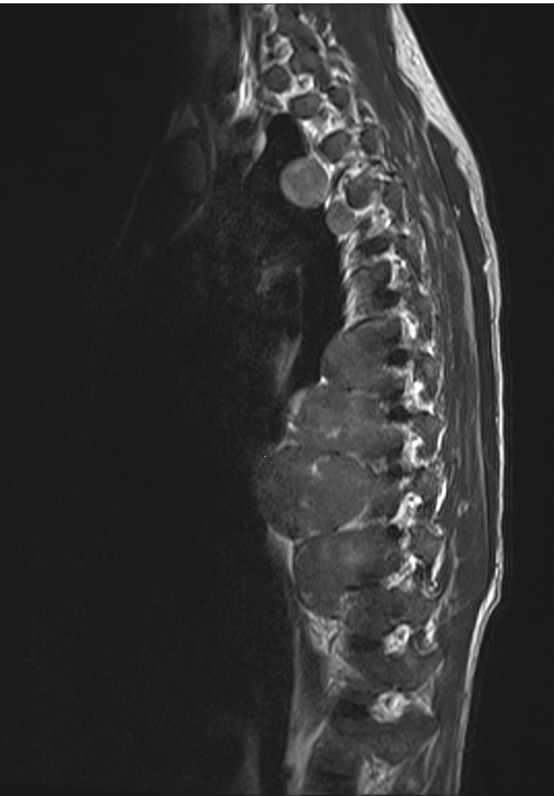

Figure 3:
Para –Sagittal T1 weighted sequence demonstrates multiple lobulated masses extending from the thoracic vertebrae which are iso – intense to the vertebral bodies. The masses extend laterally and anteriorly into the posterior mediastinum.

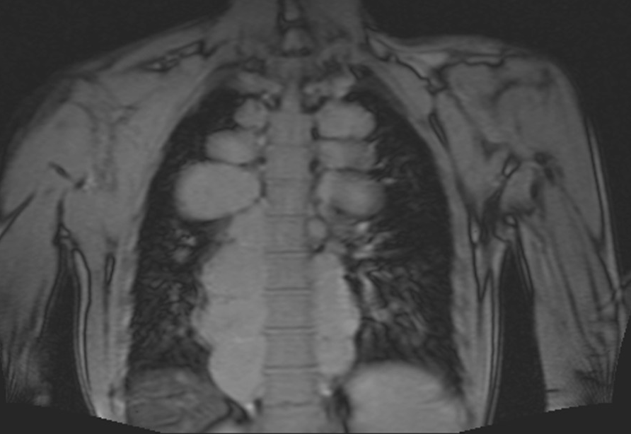

Figure 4:
Coronal T3 weighted sequence shows lobulated masses extending laterally into the posterior mediastinum, with similar signal to the adjacent vertebral bodies.

