Figure 3

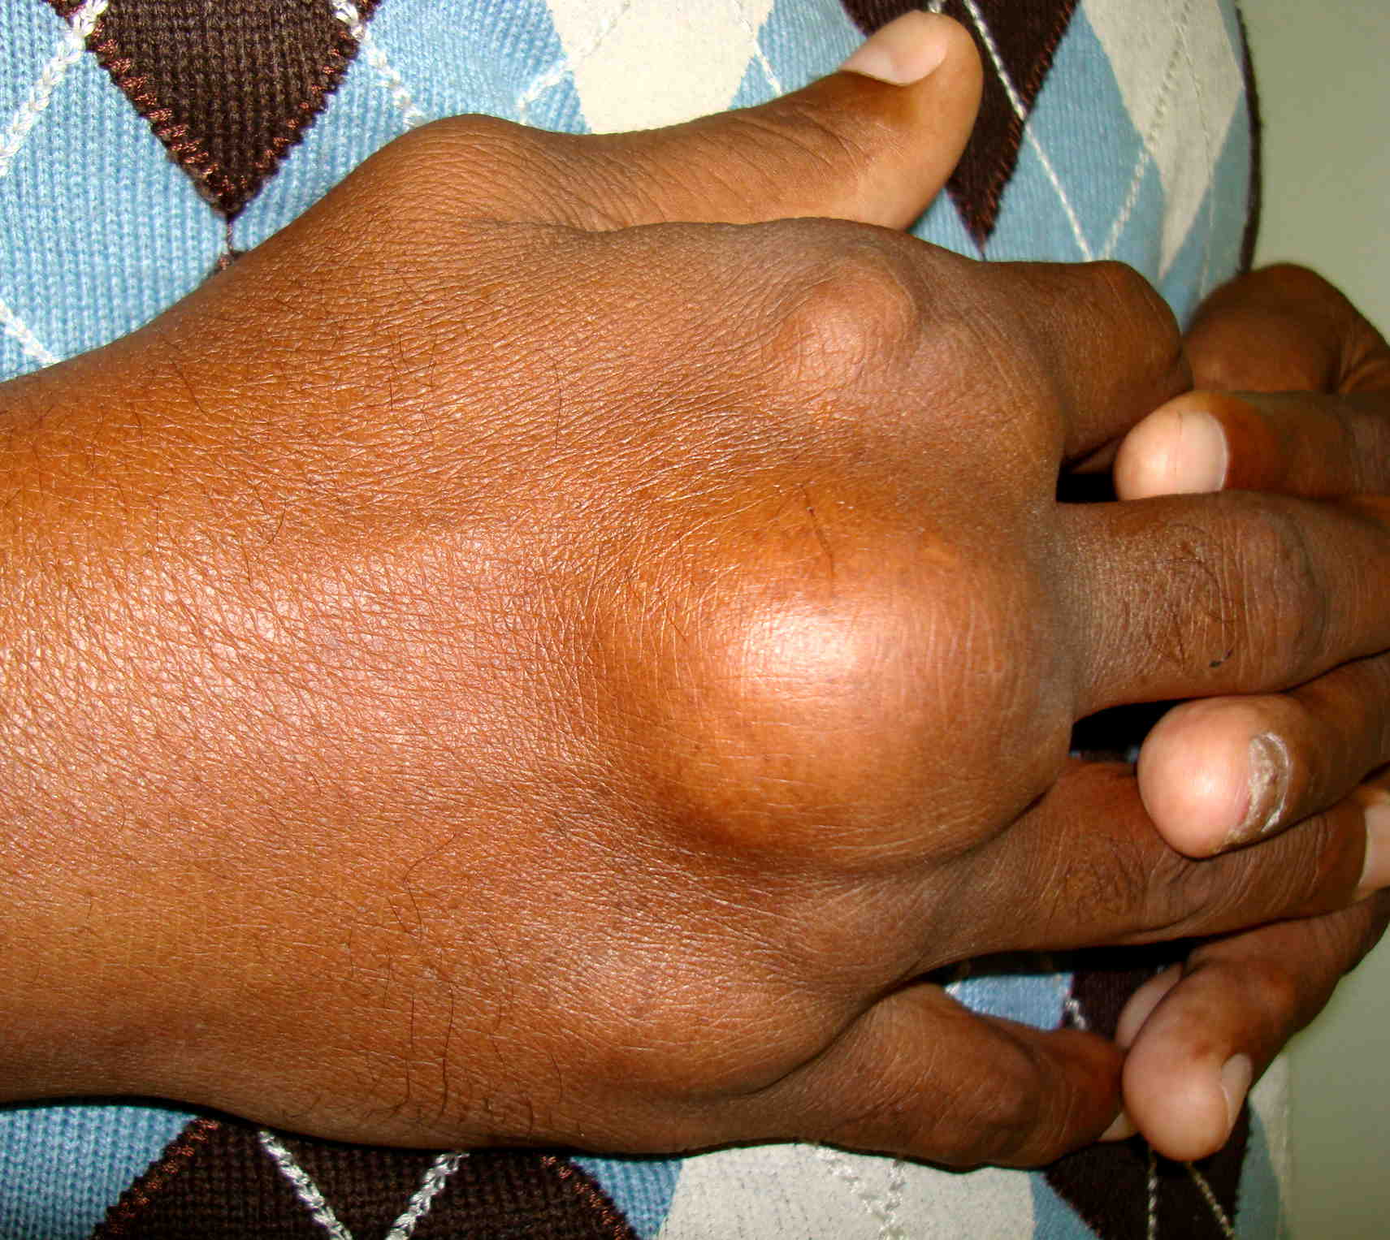

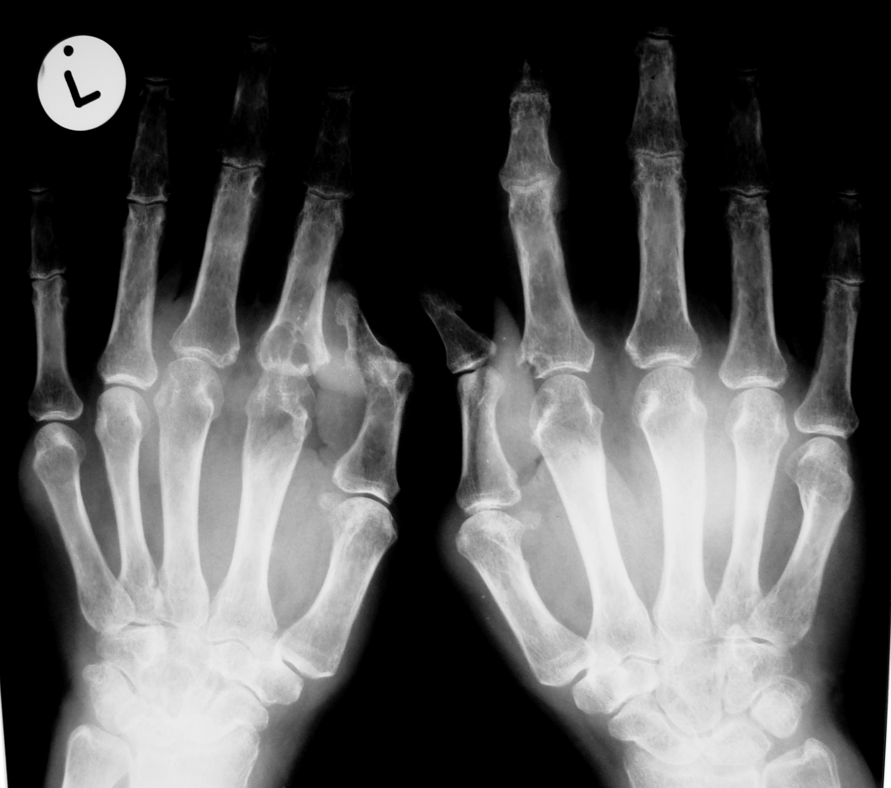

Photograph of the right hand and anteroposterior radiograph of both hands shows large soft tissue tophi around the MTP joints and typical involvement of the MTP joints by gout on X-rays..

