Figure 6a

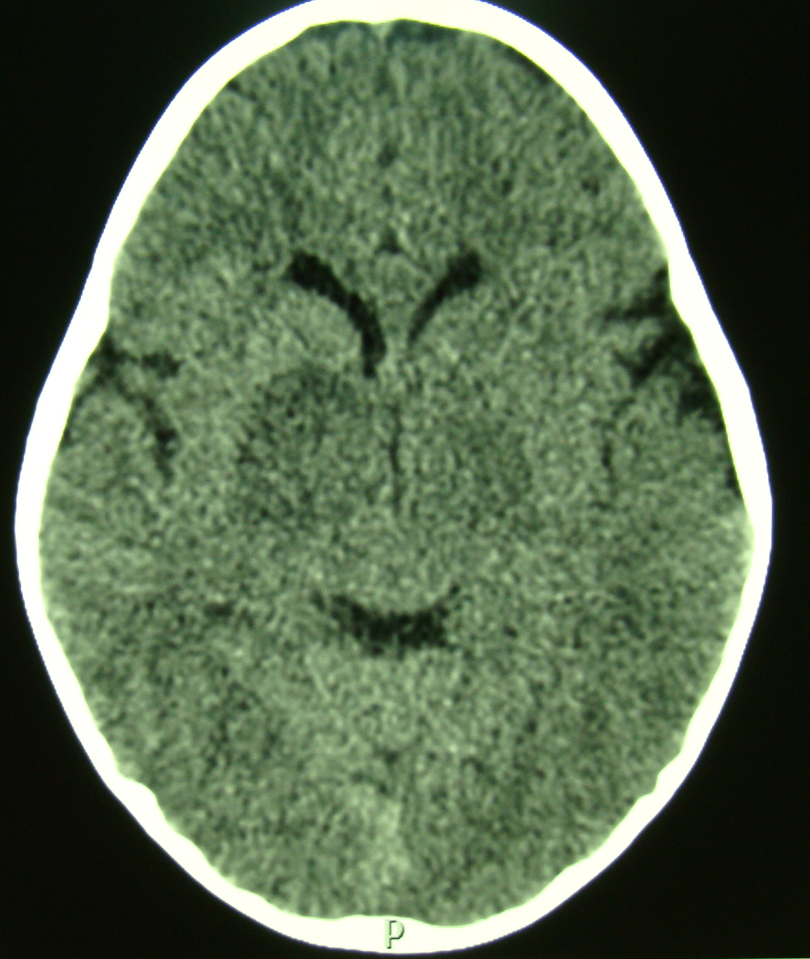

Axial non enhanced CT brain demonstrates bilateral low density lesions in the basal ganglia with no appreciable mass effect.

Figure 6b

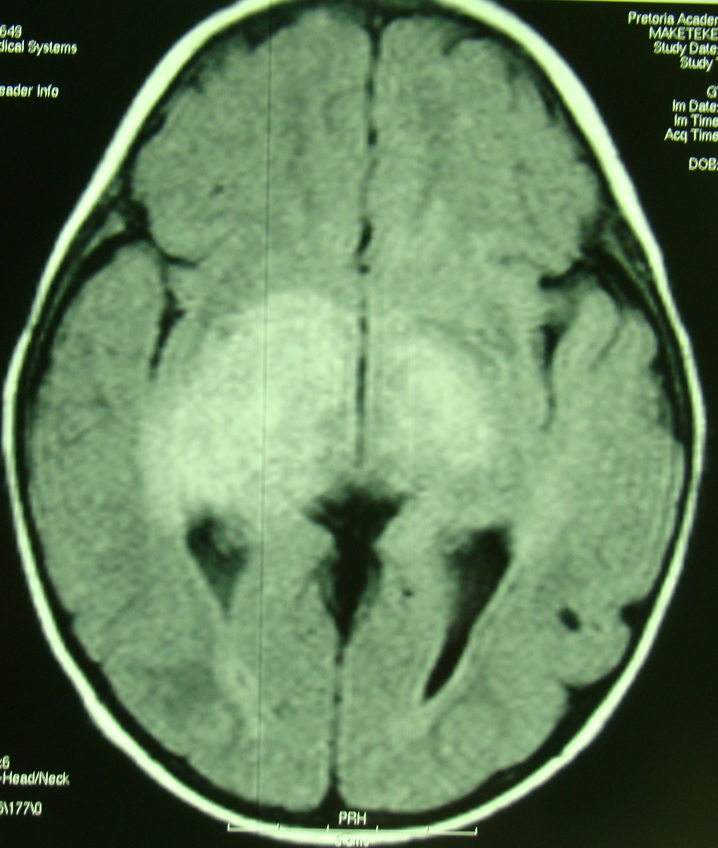

Axial FLAIR sequence of the same patient as above shows bilateral hamartomatous high signal changes in the basal ganglia (FASI) with no appreciable mass effect.

Figure 6c

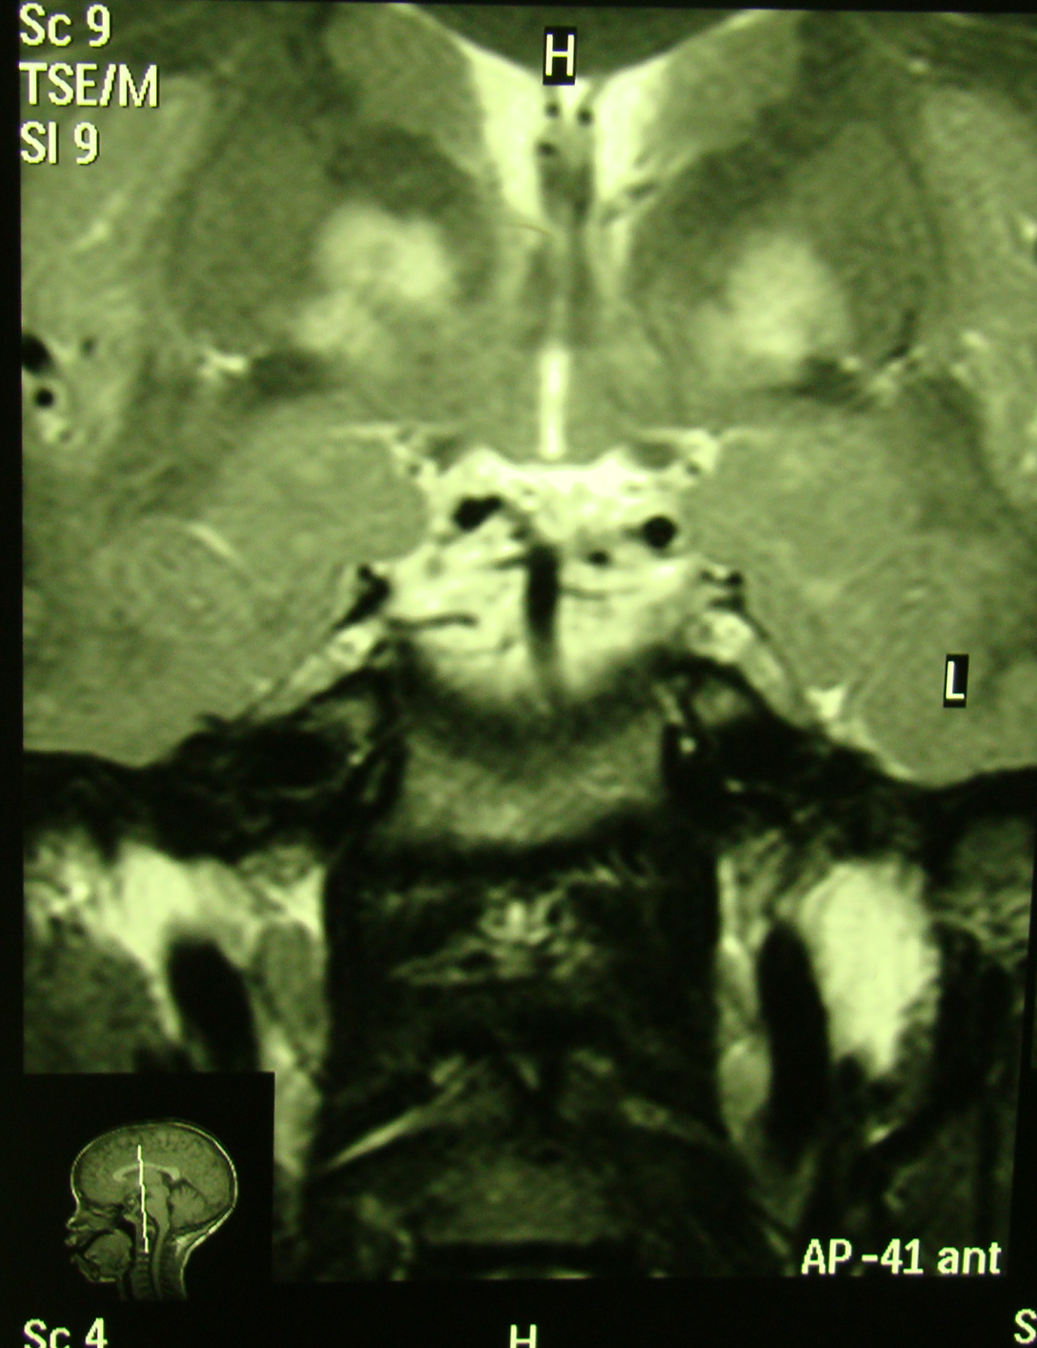

Coronal T2 weighted MRI of the same patient, note these lesions are hyperintense with fairly well defined margins and no mass effect.

Figure 6d

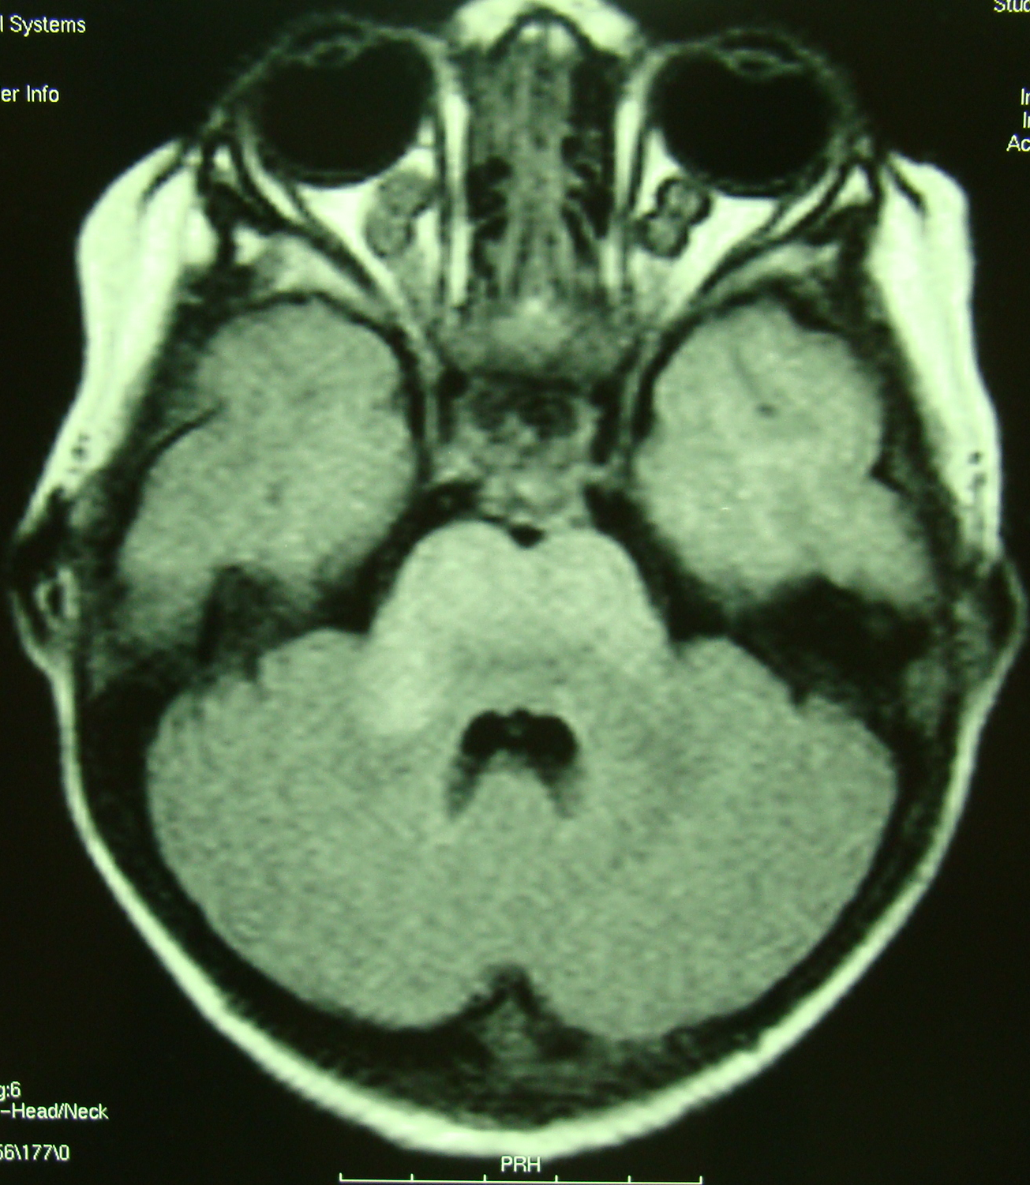

Axial FLAIR MRI sequence demonstrating bilateral optic nerve gliomas and FASI changes in the brainstem.

Figure 7
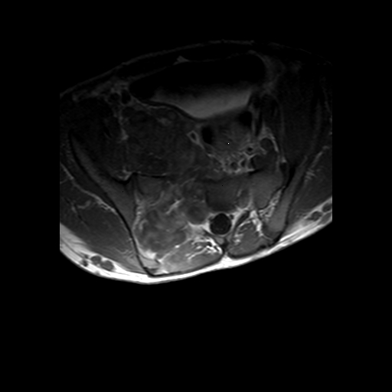

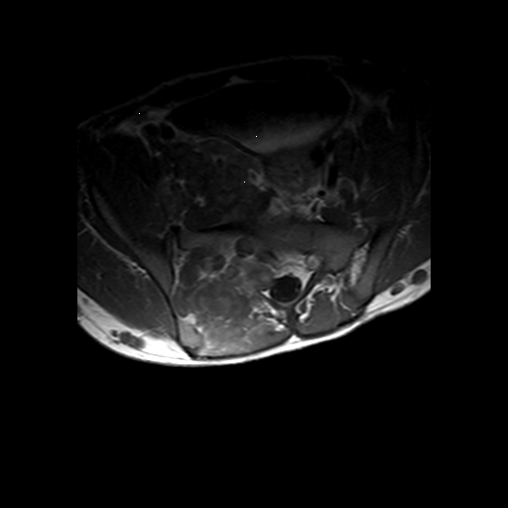

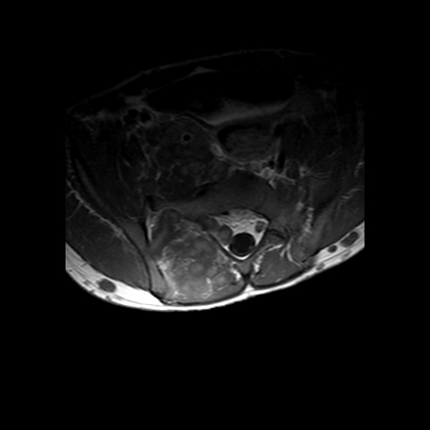

Axial T1 weighted MRI of the lumbar spine showing exiting neurofibroma along the nerve root at the level of the sacral nerve. (Courtesy of Dr Z Ebrahim).

Figure 8a
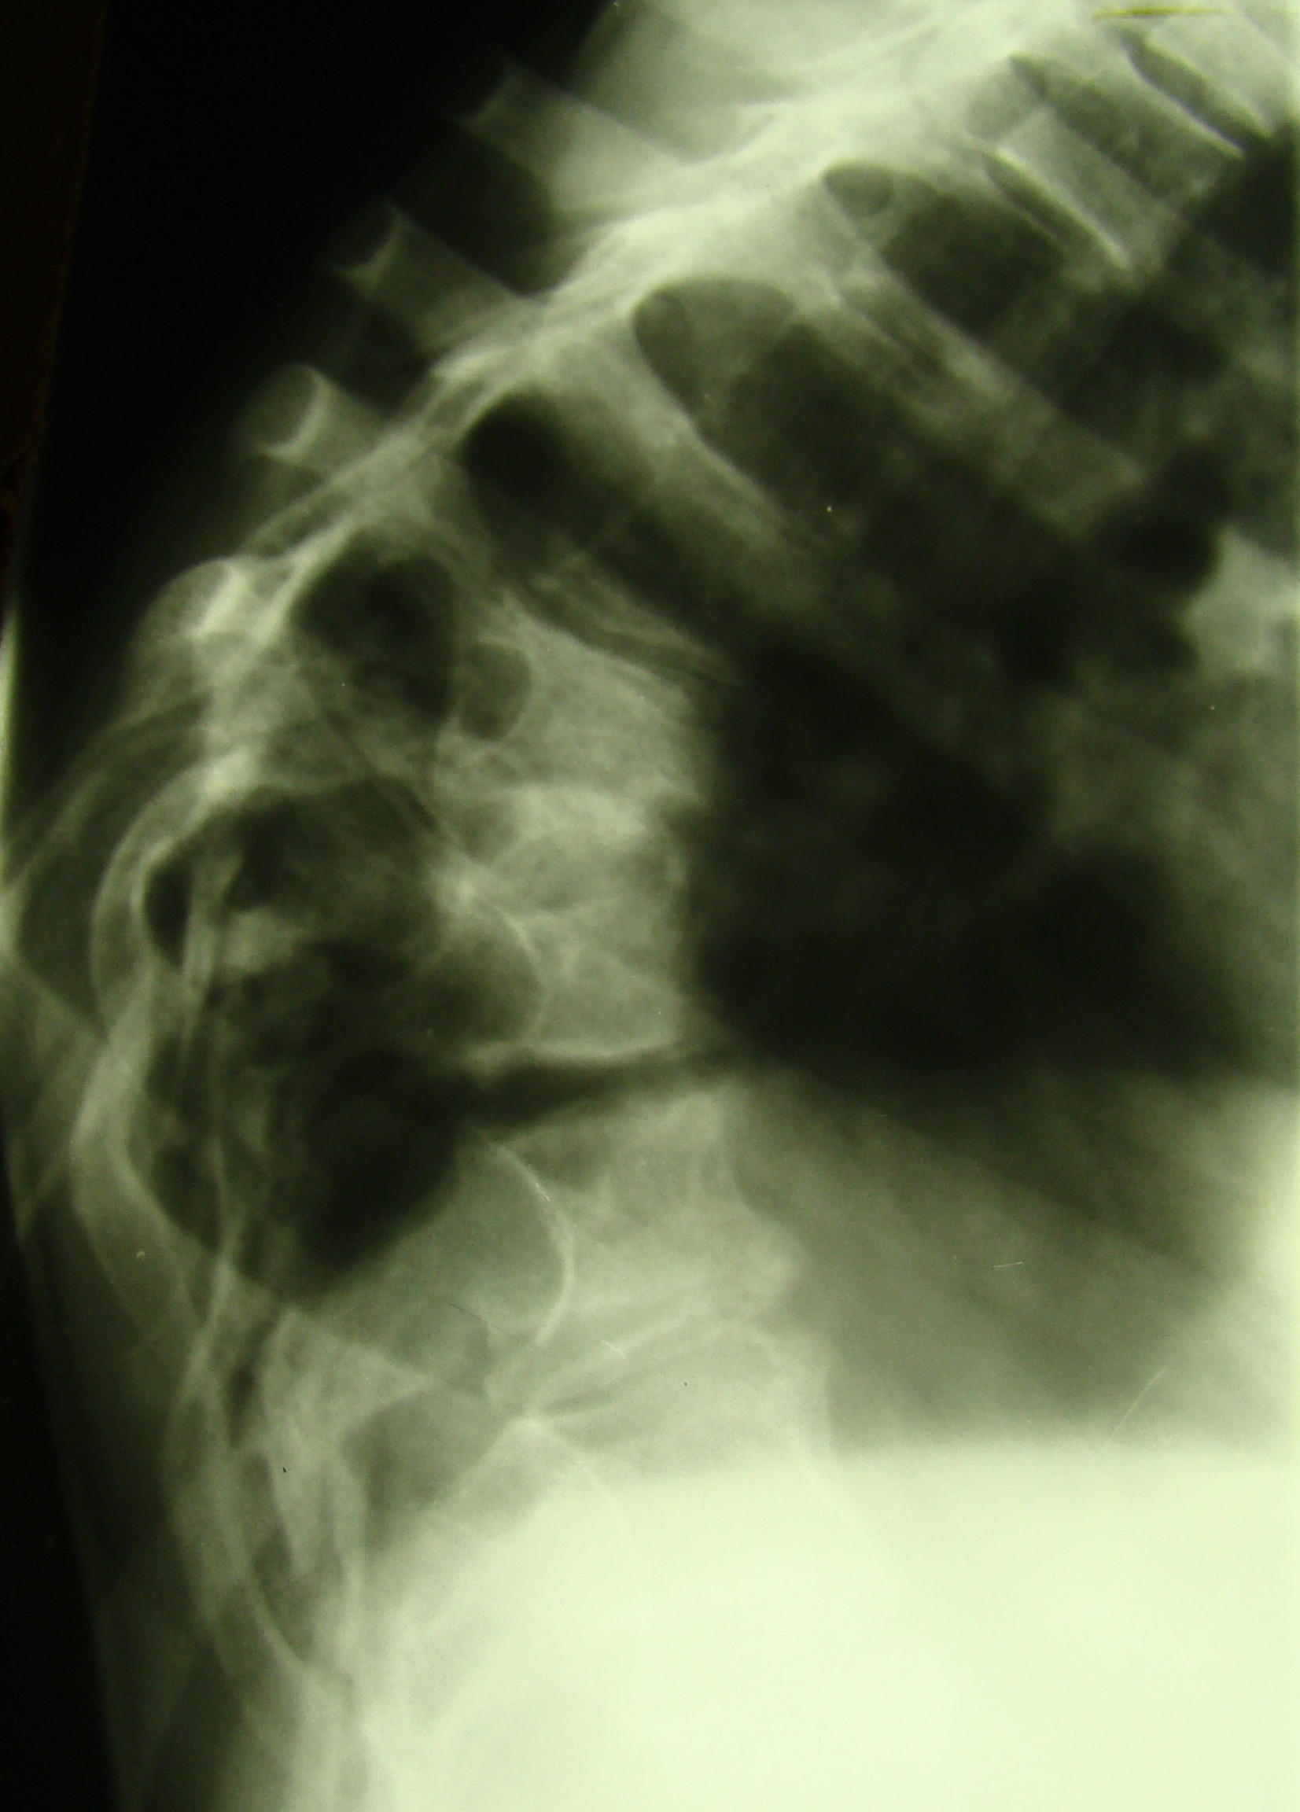

Lateral xray of the thoracic spine showing enlargement of the neural foramina at multiple levels and posterior vertebral scalloping gibbus due to multiple dumbel tumors and dural ectasia.

Figure 8b
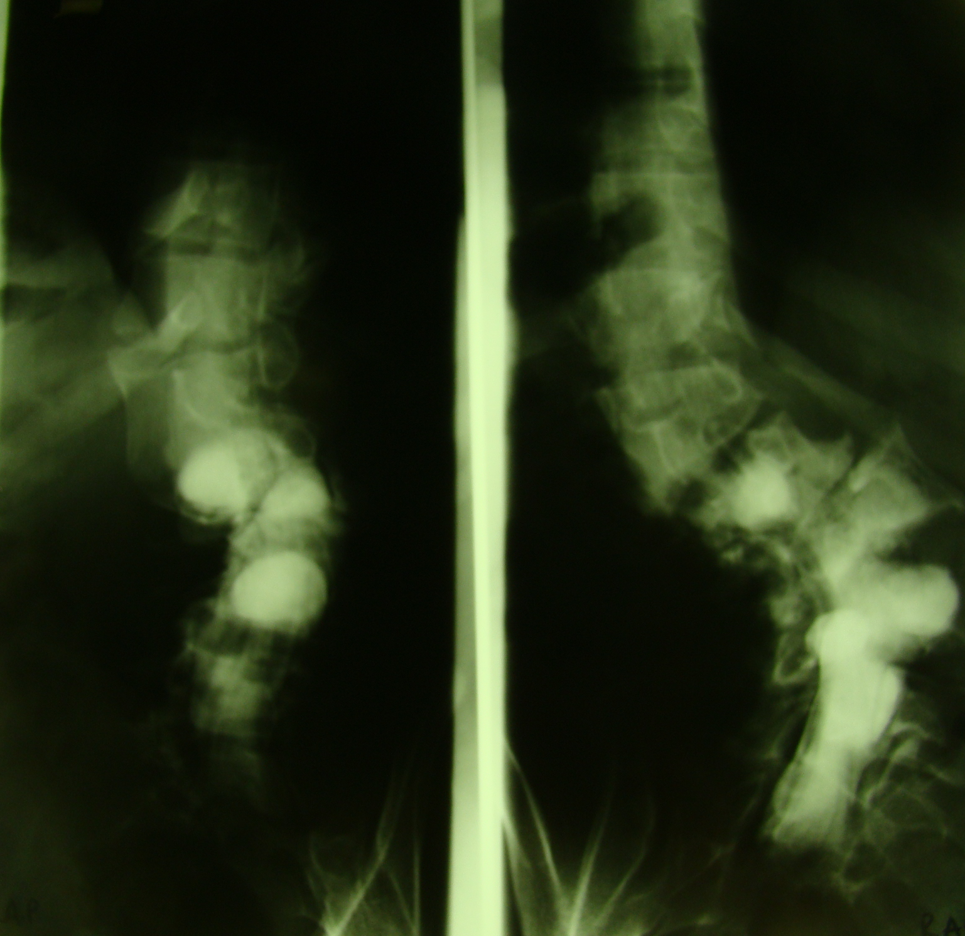

Myelogram of the lumbar spine in a different patient showing multi – level vertebral anomalies and dural ectasia.

Figure 8c

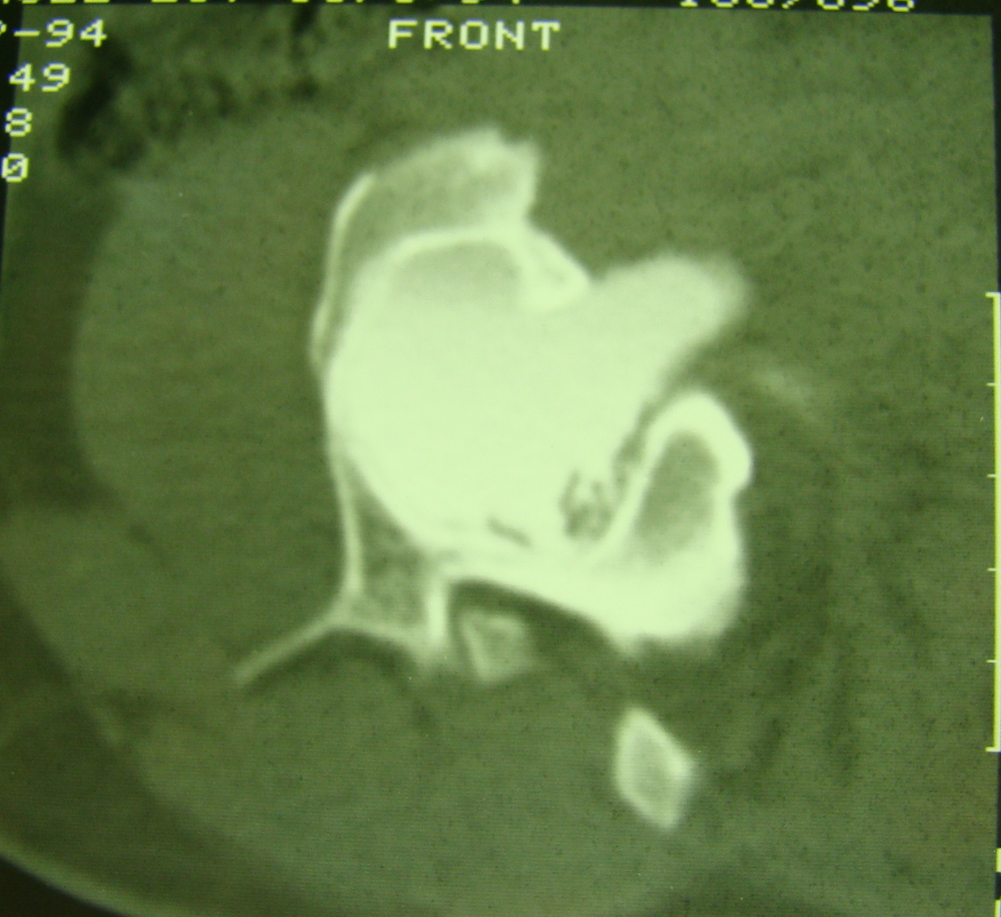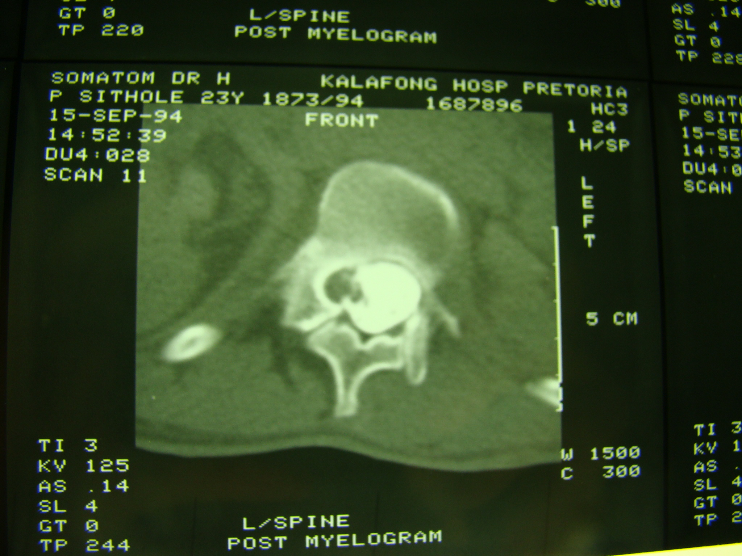

CT myelogram of the same patient in 8b with dural ectasia.

Figure 9a
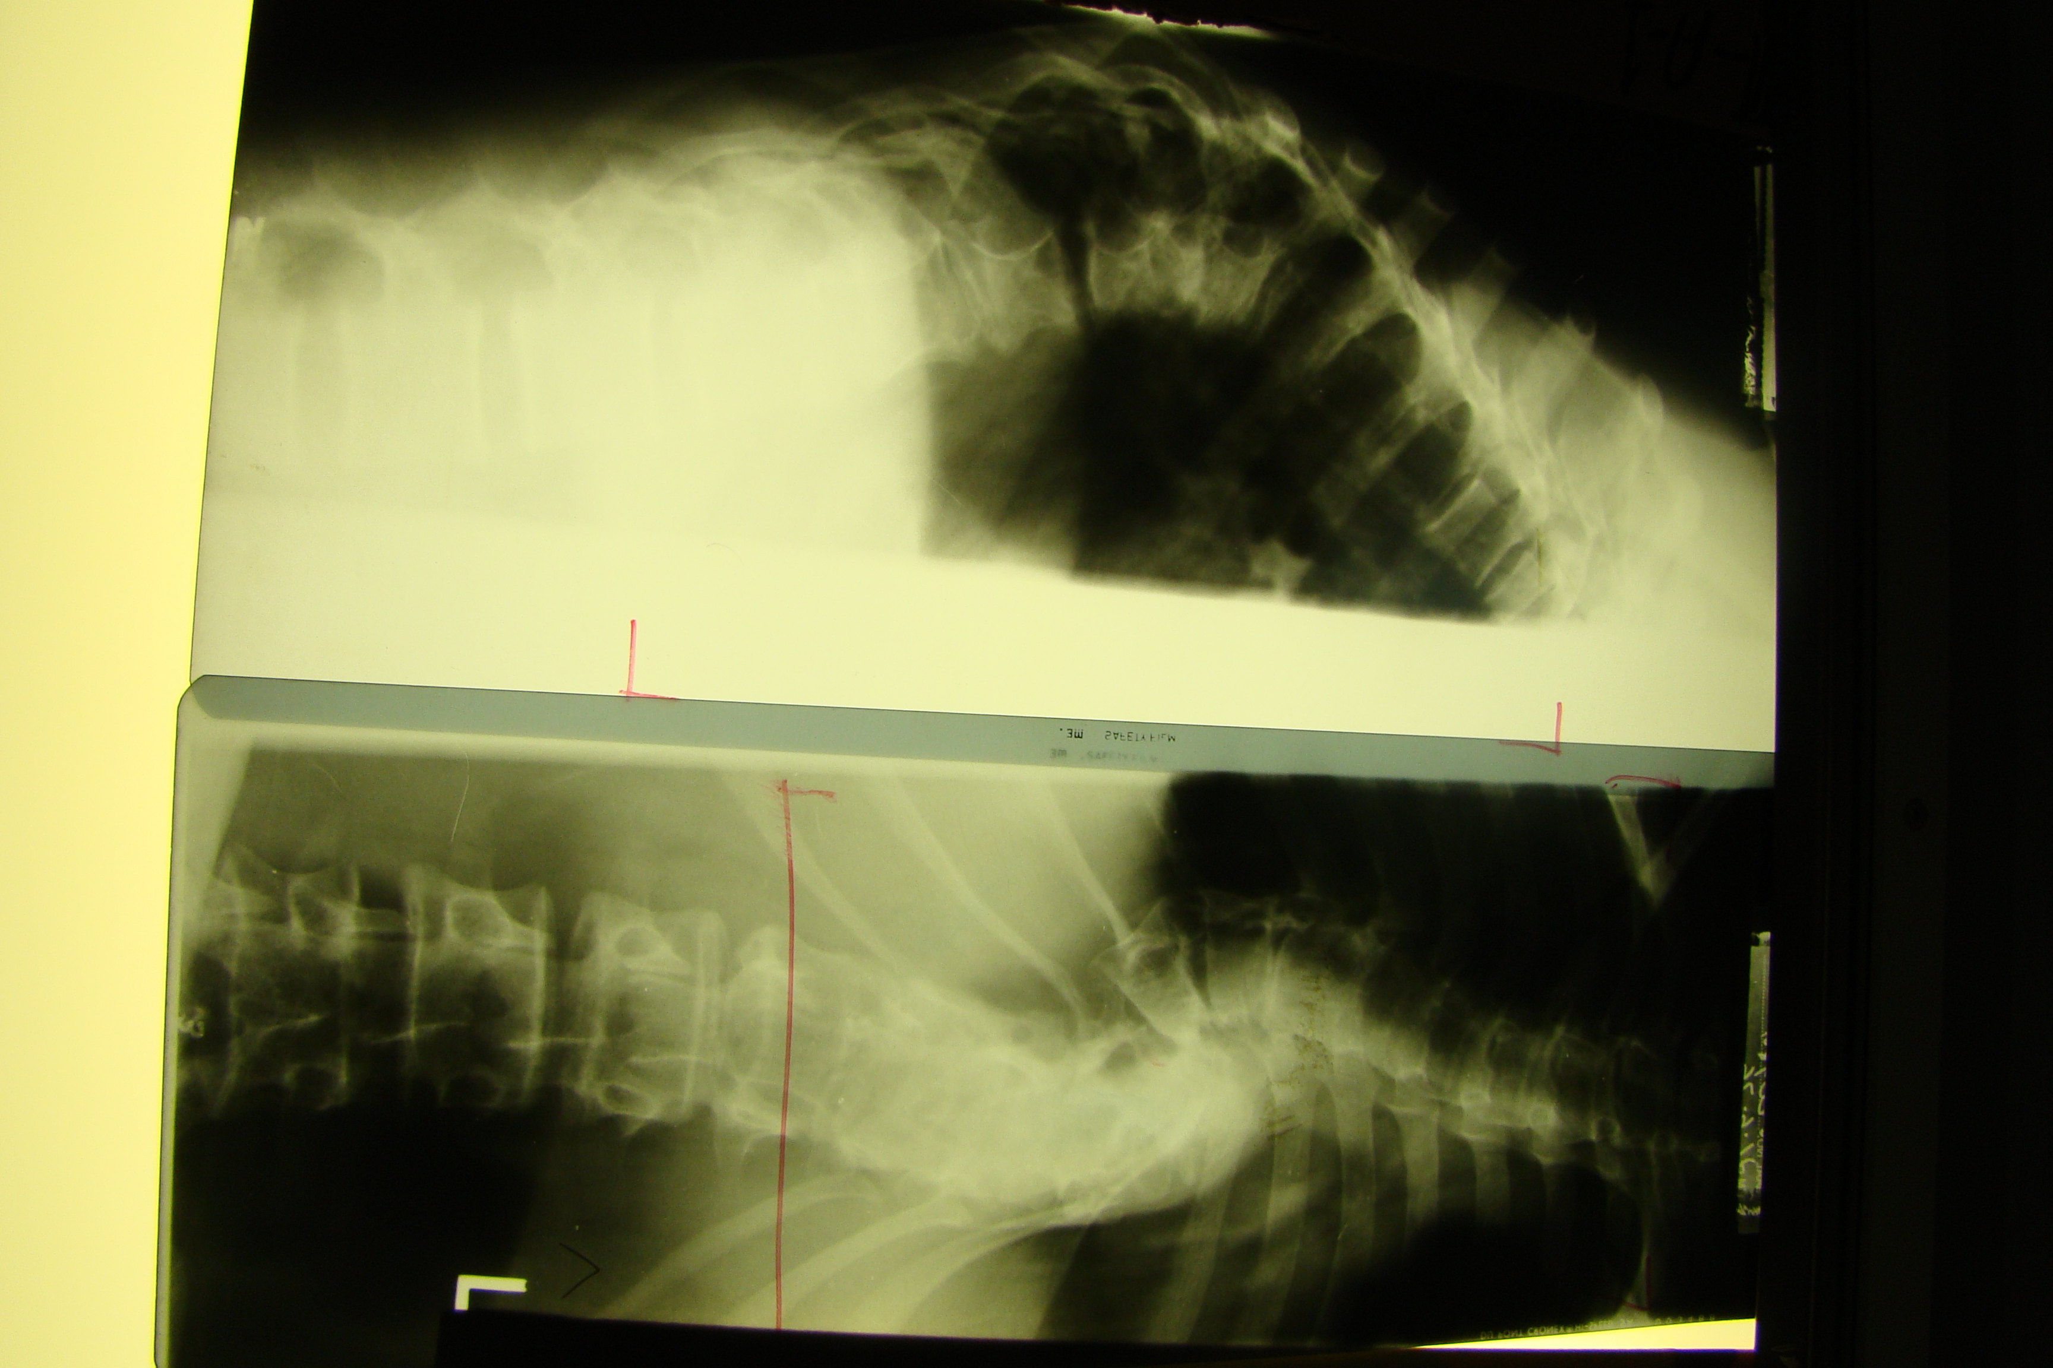

Lateral and frontal radiographs of the thoracic spine demonstrating kyphoscoliosis, which may either be due to vertebral anomalies or to large meningoceles or neurofibromas.

Figure 9b

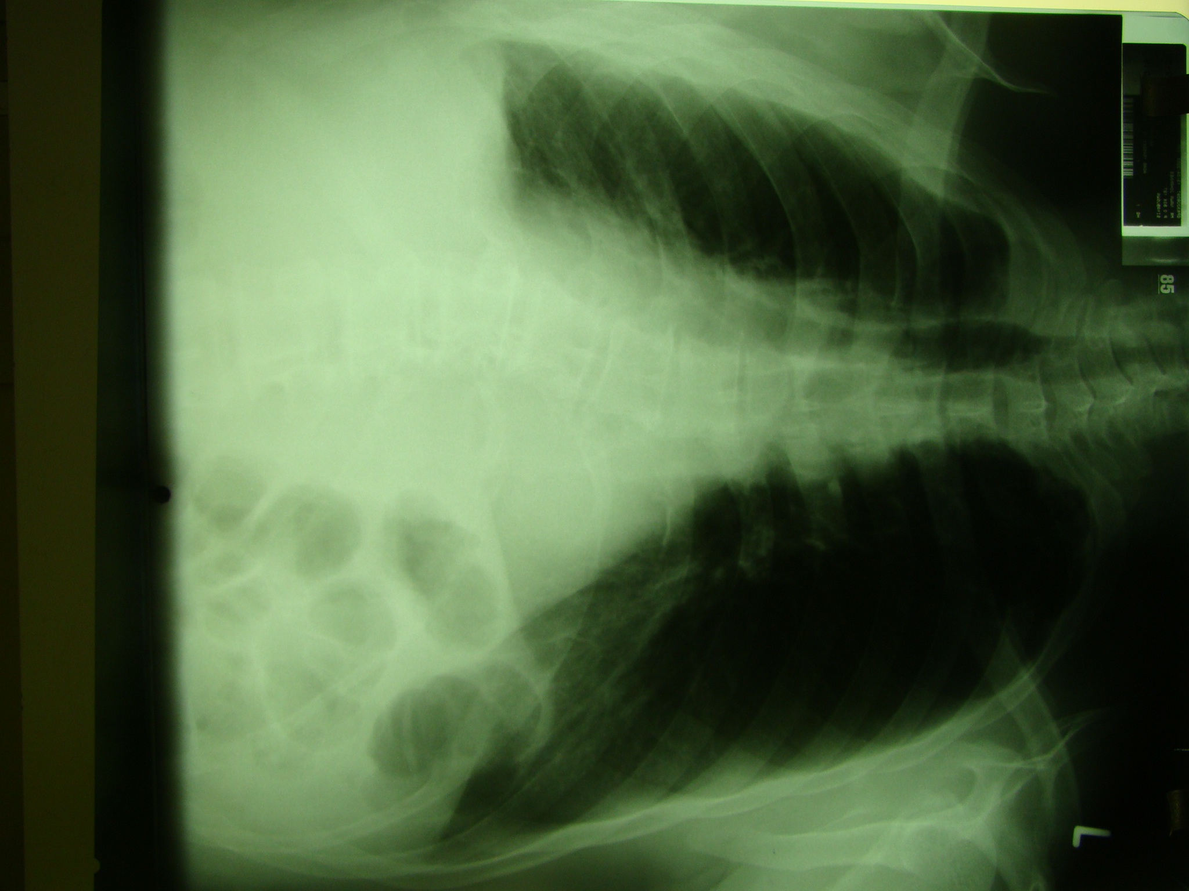

Frontal chest radiograph demonstrates dextroscoliosis of the lower thoracic spine associated with large soft tissue left para-vertebral mass, erosion and thinning of the tenth, eleventh and twelfth ribs on the left and left lateral vertebral body scalloping.

Figure 10

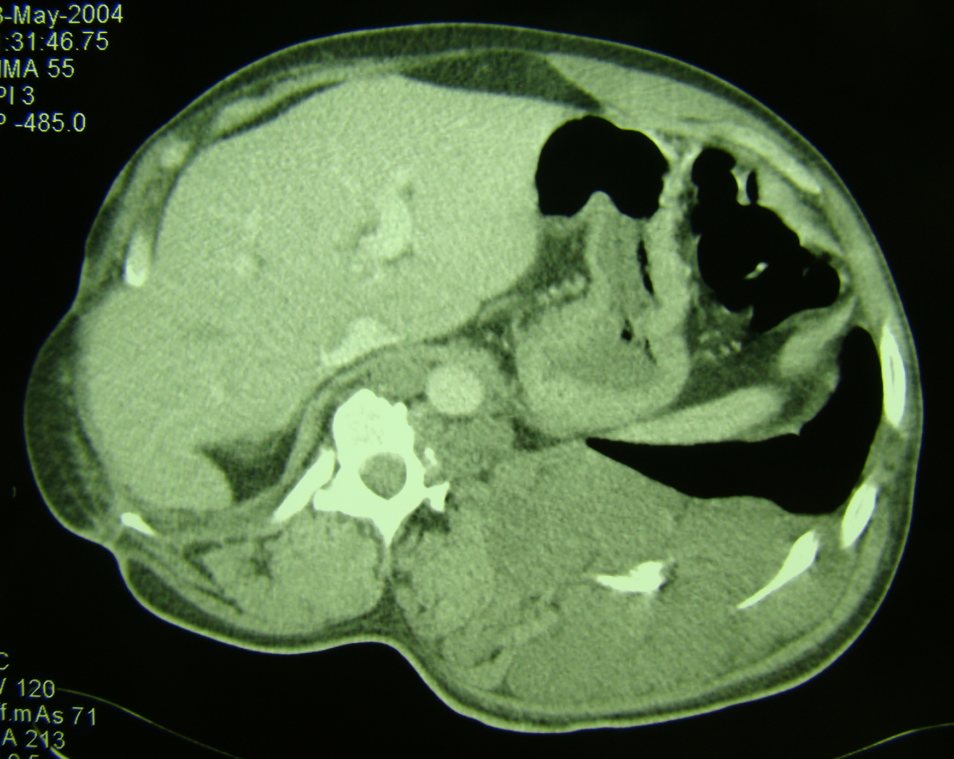

CT scan of the above patient showing a large plexiform neurofibroma on the left side causing spine and rib changes.

Figure 10a

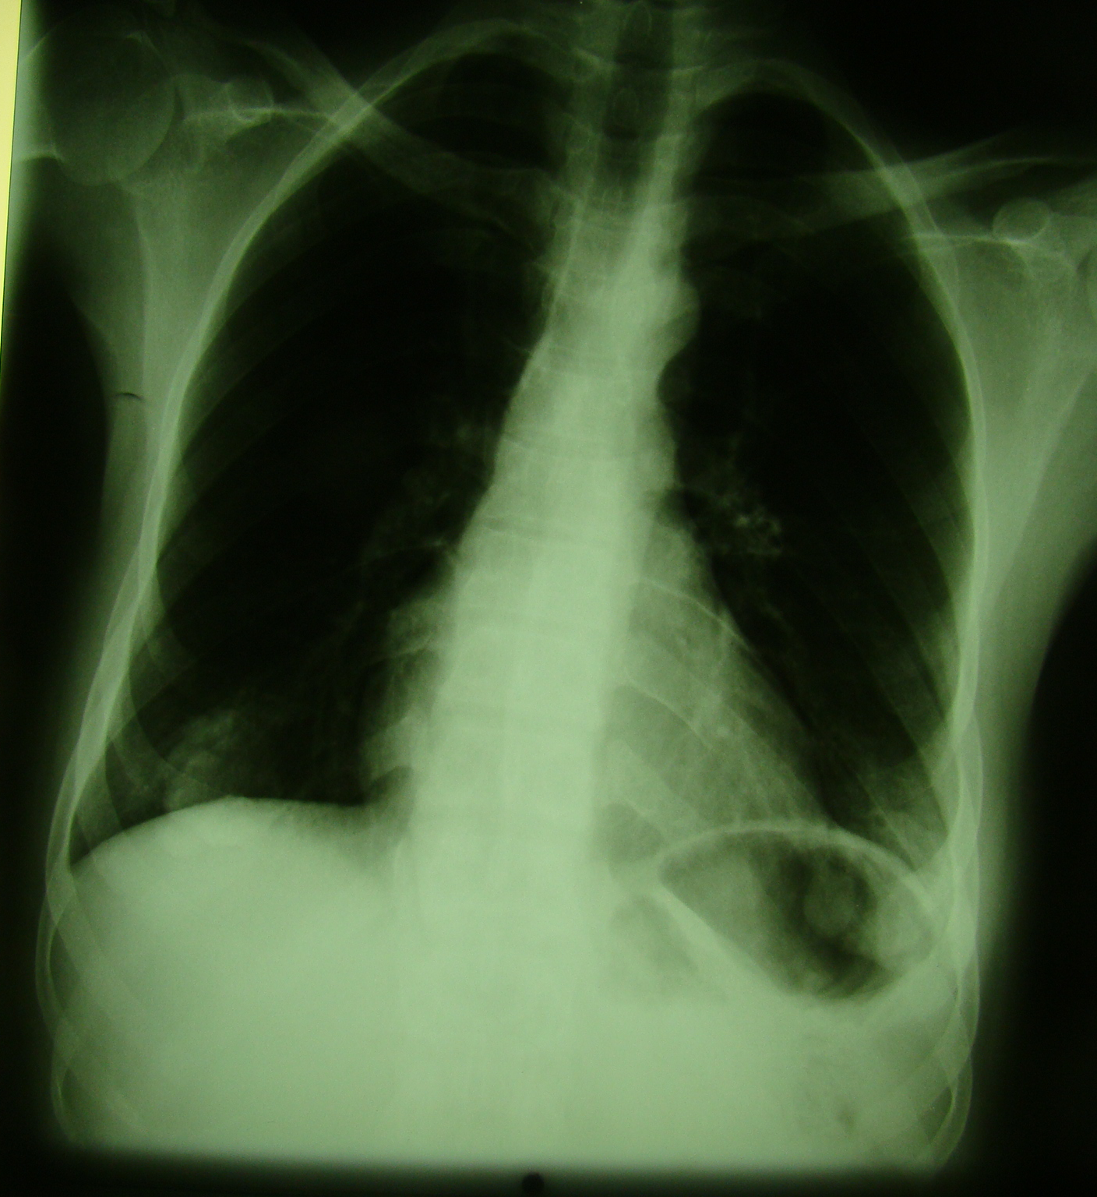

Frontal chest radiograph showing bilateral cutaneous neurofibromas of the areola projecting over the lung fields.

Figure 10b

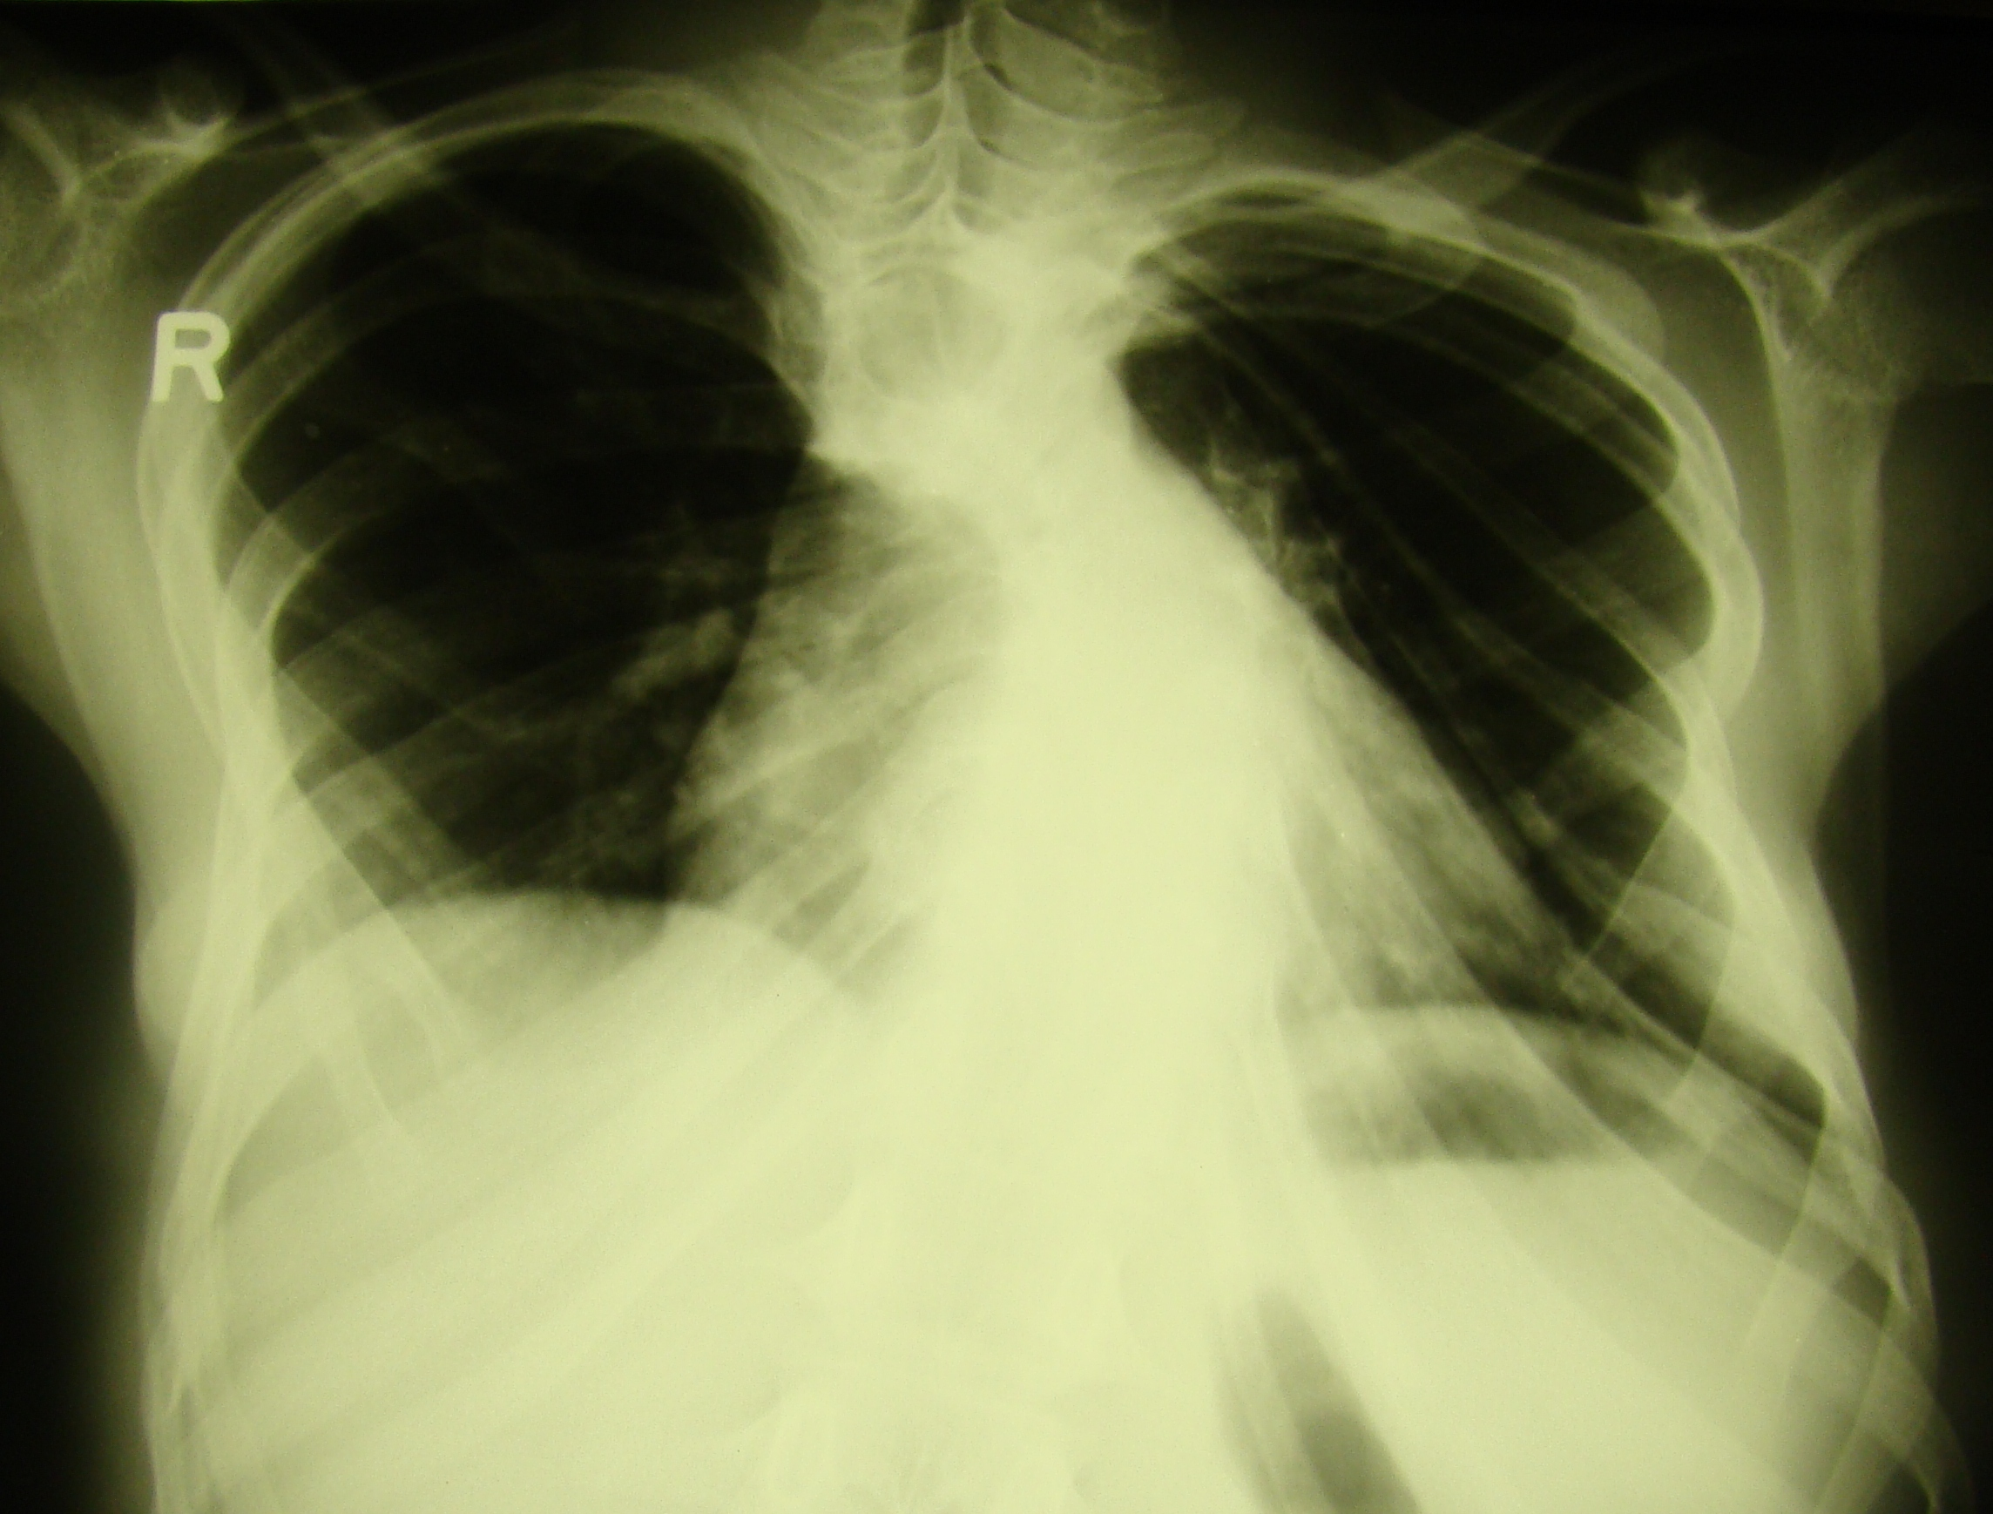

Chest xray showing twisted ribbon ribs.

