Figure 4

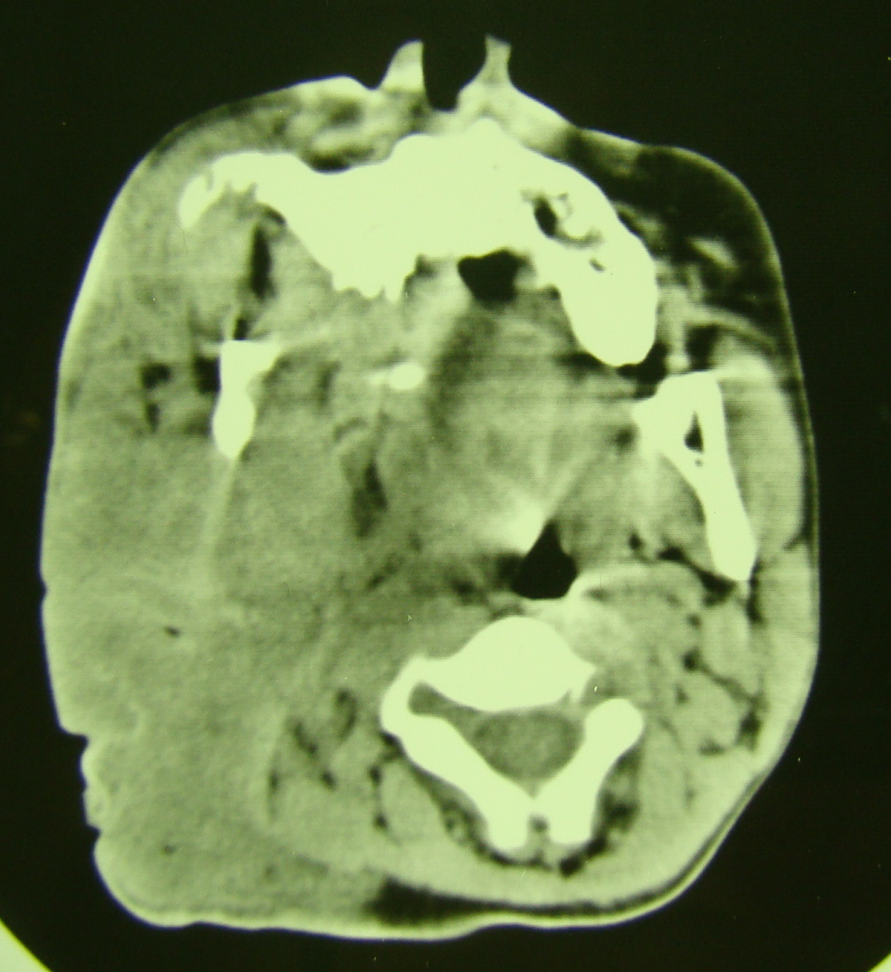

Axial CT scan of the skull base showing a large plexiform neurofibroma on the right - note the characteristic poorly delineated diffusely infiltrating mass.

