Figure 2a

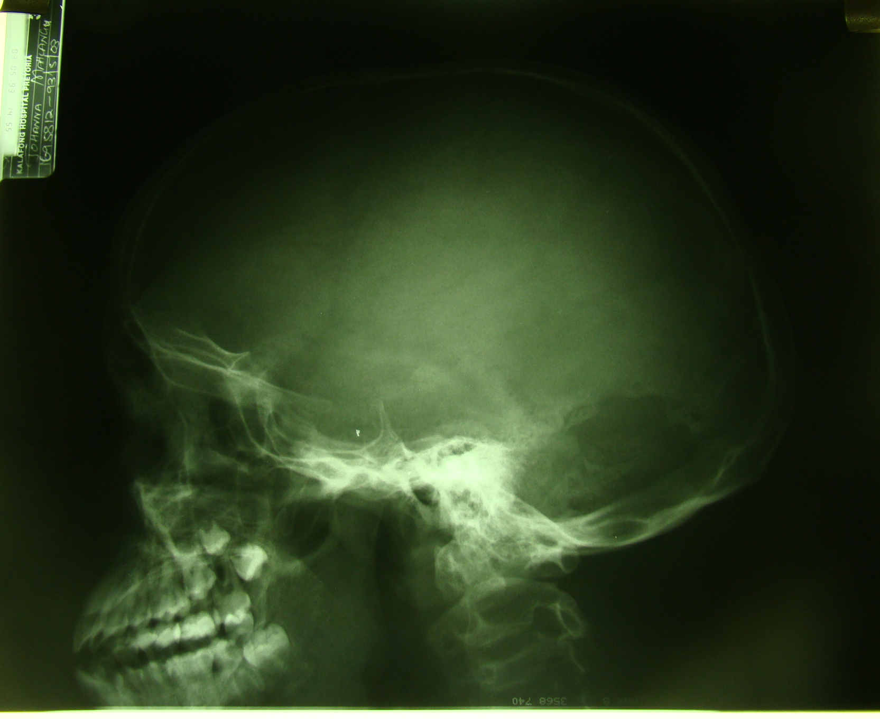

Lateral skull radiograph demonstrates defect in the lambdoid suture.

Figure 2b
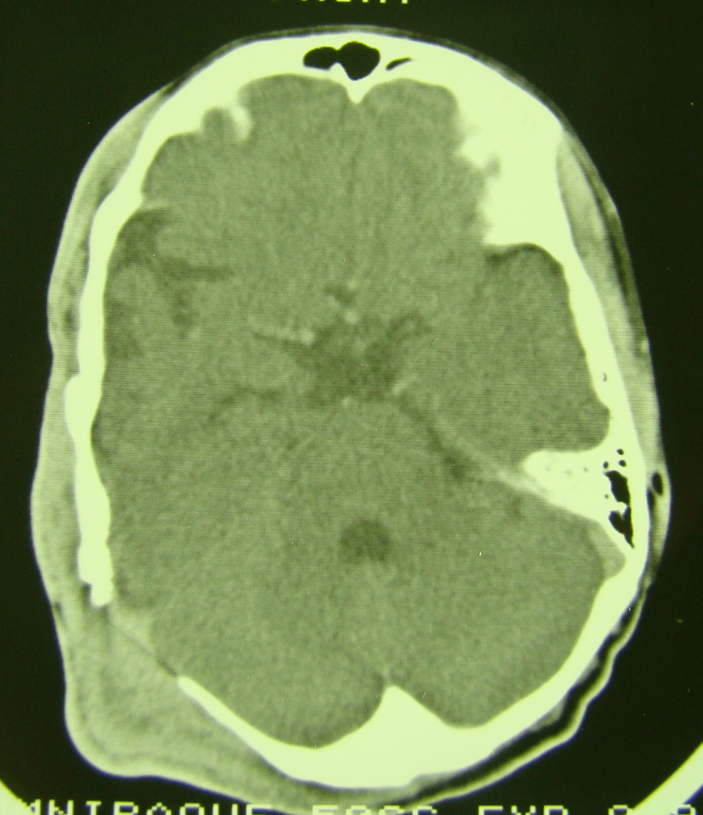

Contrast enhanced axial CT brain with right lambdoid suture defect with an overlying plexiform neurofibroma.

Figure 2c

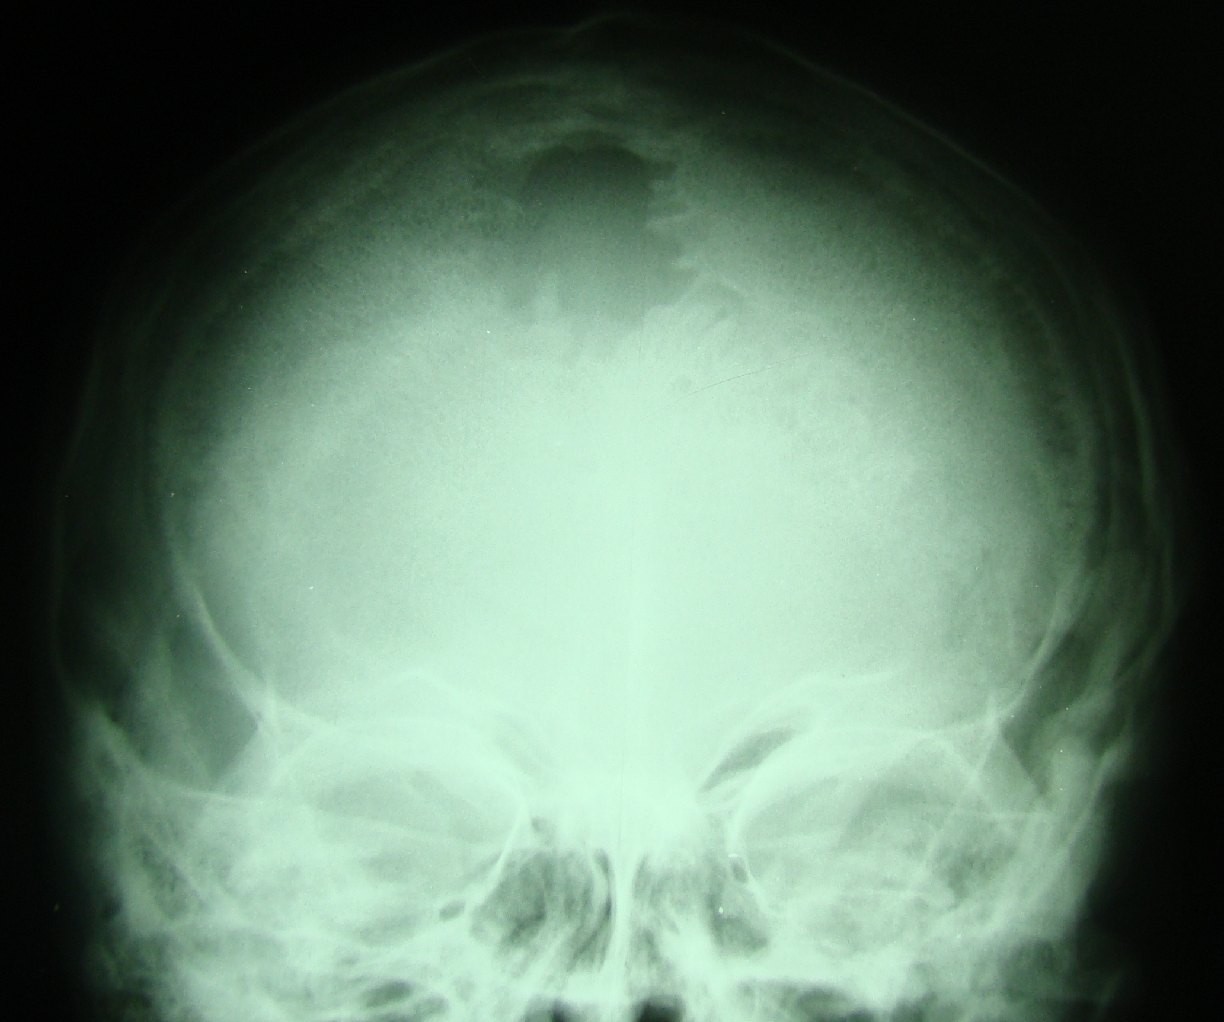

Another patient with a large parietal defect.

Figure 2d

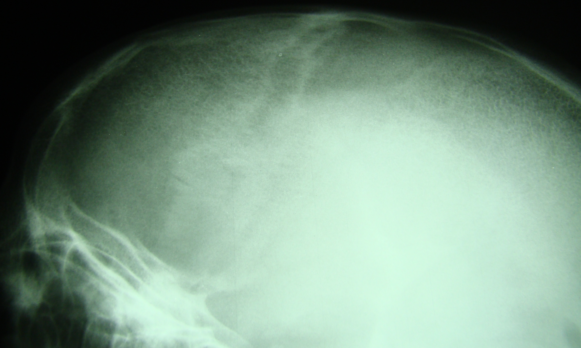

Coronal sutural defect – less commonly seen.

