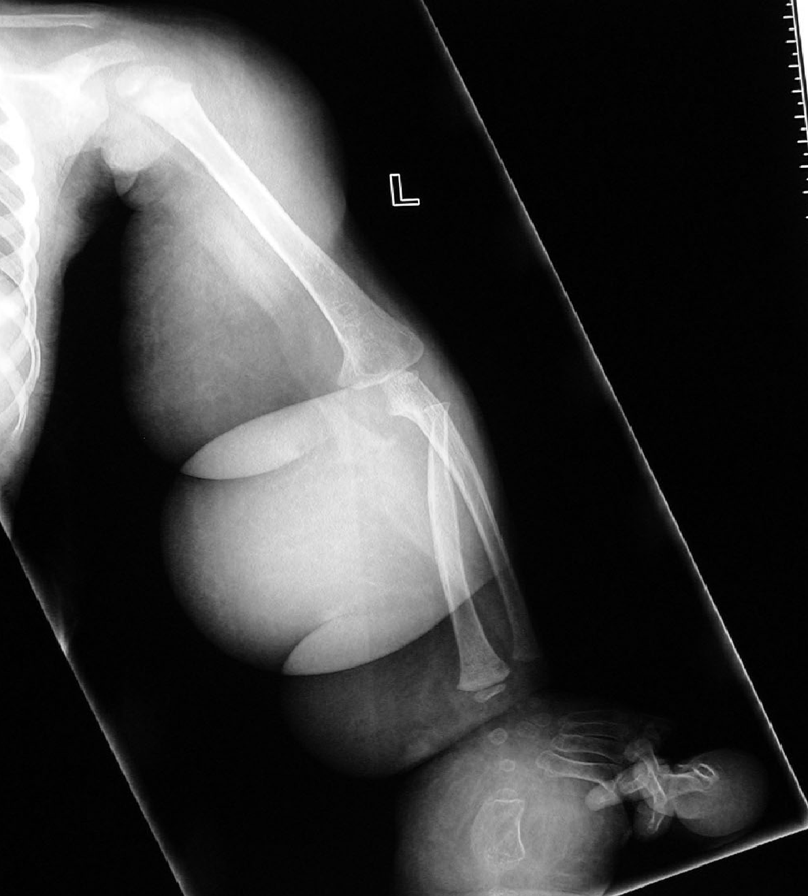

Fig 1. Radiograph of the (L) upper extremity of the patient described in case 1 demonstrates diffuse soft tissue swelling involving the entire upper limb. Soft tissues are lucent suggestive of fat. Multiple skin folds are evident. Marked osseous gigantism of the 1st and 2nd fingers noted. Humerus, radius ulnar and the bony elements of the 3rd, 4th and 5th fingers are within normal limits.

