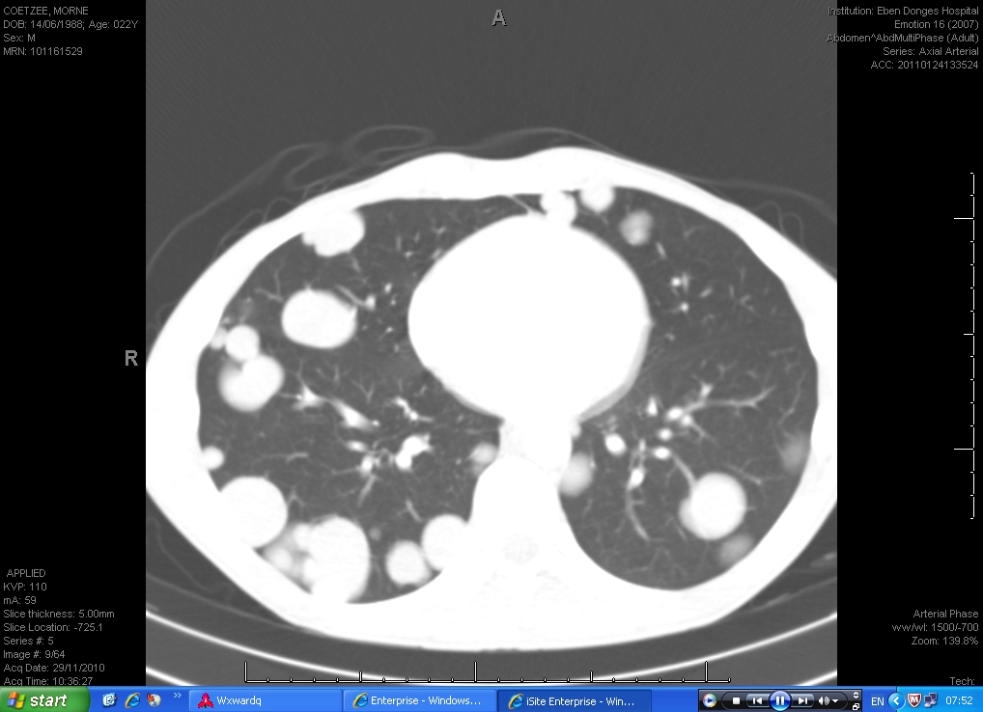
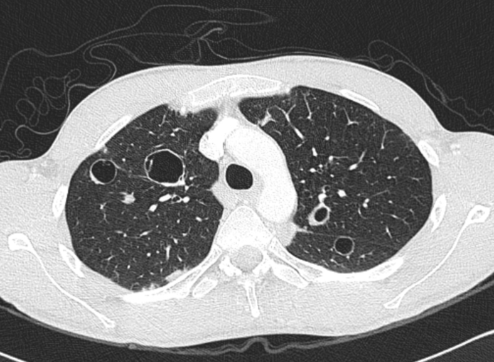
Fig. 1: Chest computed tomography of metastatic testicular cancer. (A) Pre-treatment: Note bilateral multiple lung nodules and masses, and (B) Post-treatment: Note multiple thin-walled cystic lesions.
A
B

