Illustrations and legend

Fig 1 (a and b). Axial and coronal contrast-enhanced CT of the abdomen demonstrating large right retroperitoneal abdominal and pelvic haematoma (arrow) with right-sided focal area of contrast extravasation at the expected location of the right ovarian artery. Ascites also present.

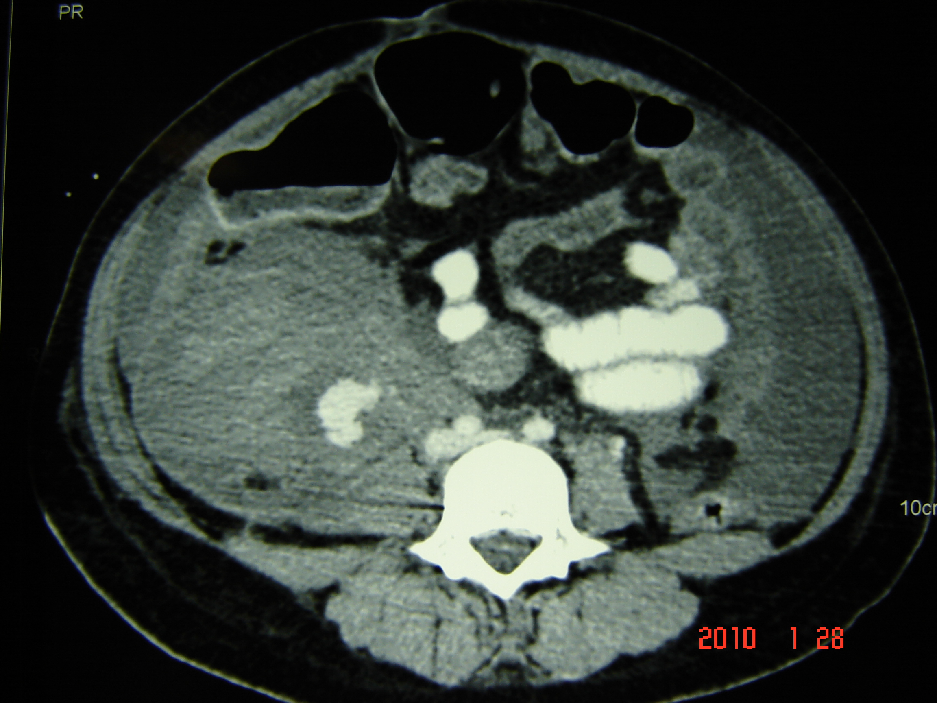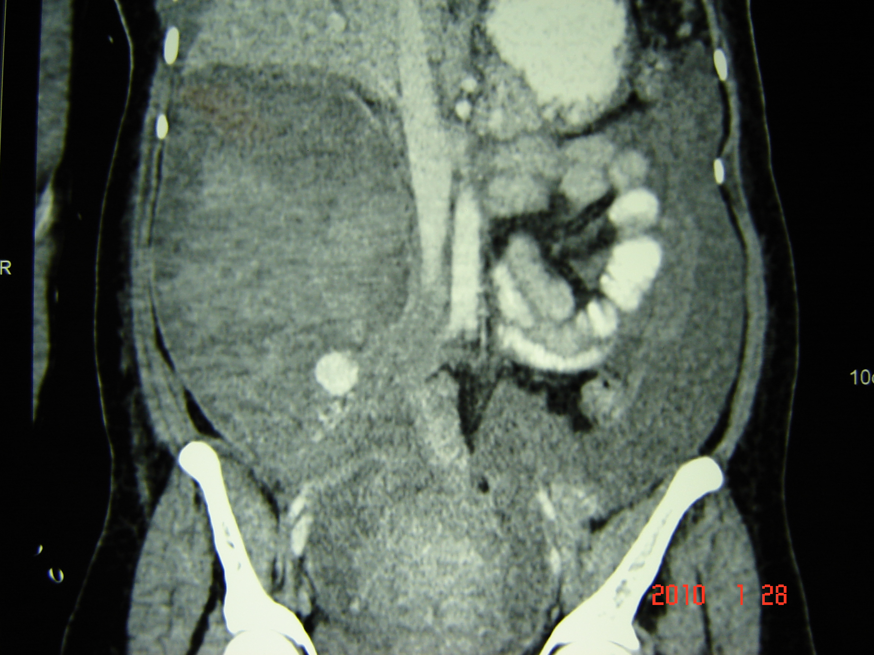
(a) (b)

Fig 2 (a and b).
(a) Angiogram demonstrating ovarian artery aneurysm/ contrast extravasation (arrow)
(b) Following successful coil embolization of the right ovarian artery.

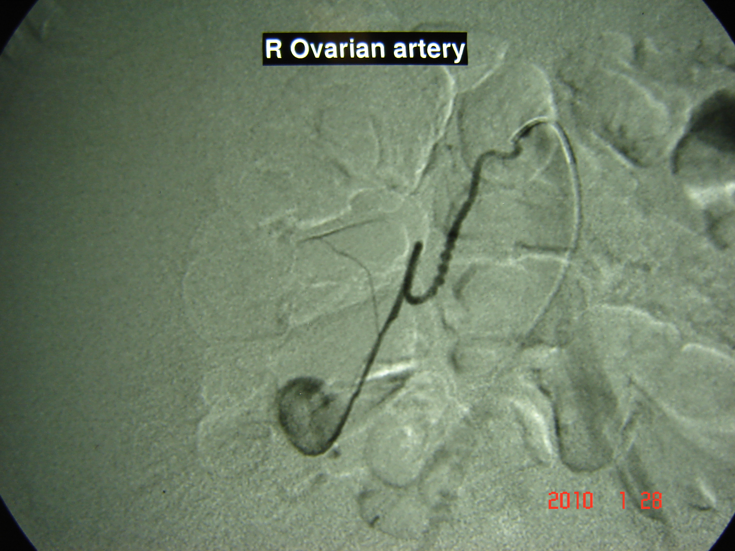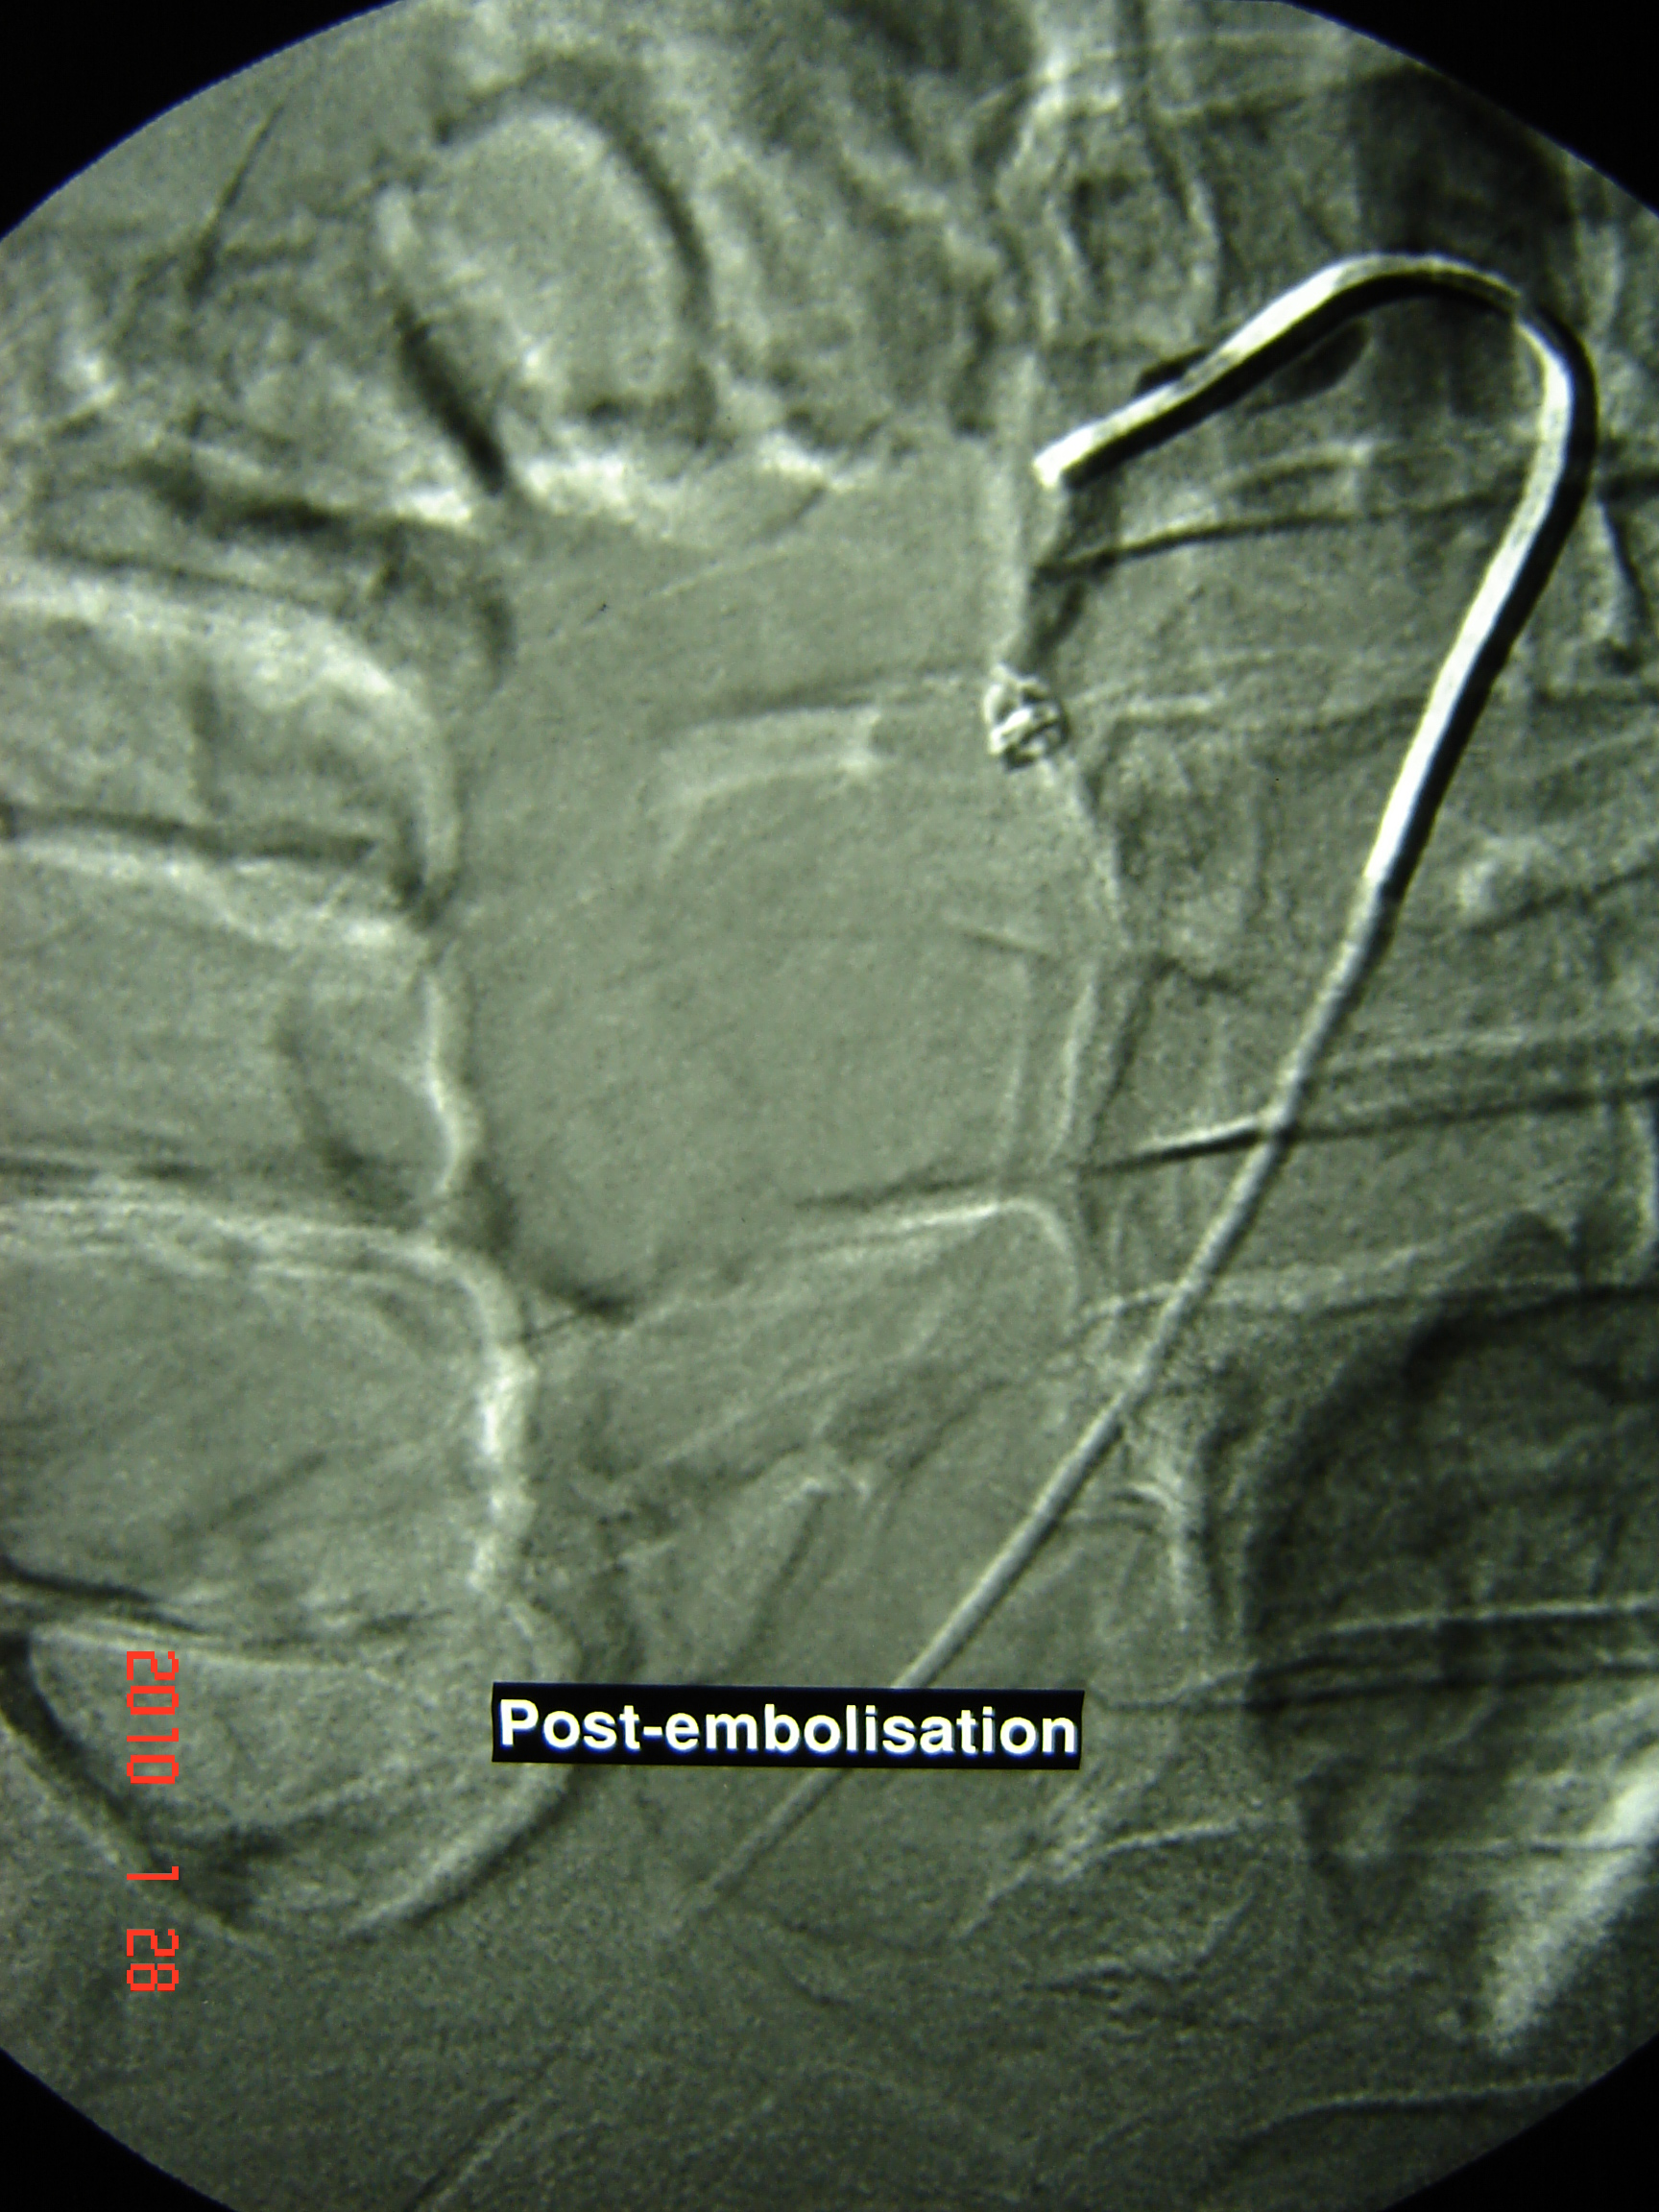
(a) (b)

