The “Bamboo” identity – Xray findings of Ankylosing Spondylitis revisited
Figures:
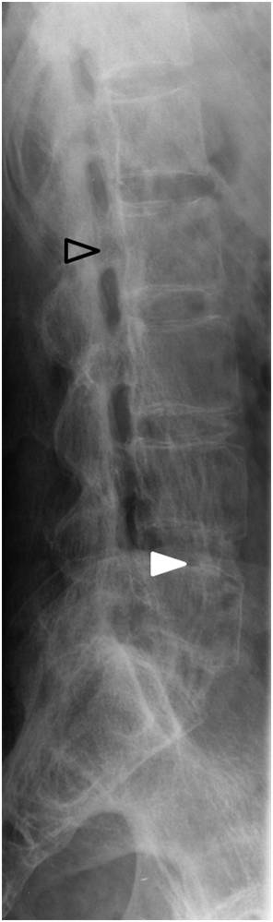
Fig 1. Lateral lumbar spine view. Note the “squaring” of the lumbar vertebrae (open arrow head), together with the central radiodense region in the vertebral endplate of the fifth lumbar vertebrae, superiorly (white arrow head). This is known as an Andersson lesion.

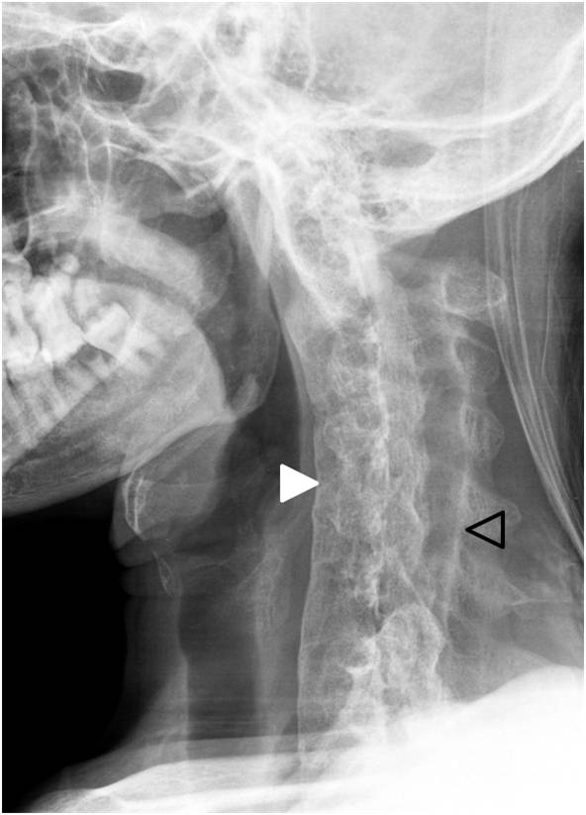

Fig2. A lateral cervical spine xray. The arrow head depicts syndesmophytes, representing calcification of the anterior portion of the annulus fibrosis. Calcification of the interspinous ligaments can also be seen (open arrow head)

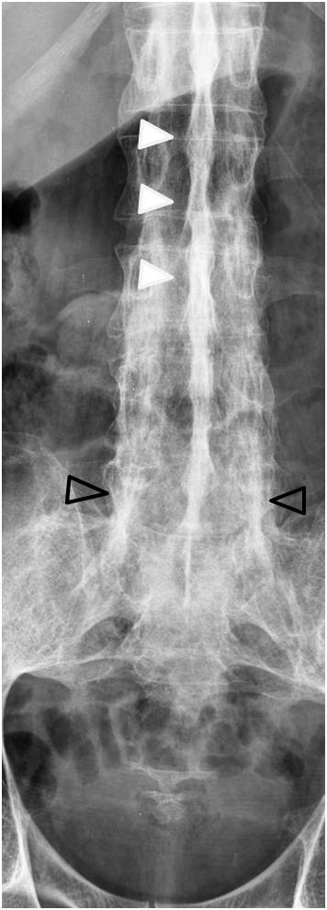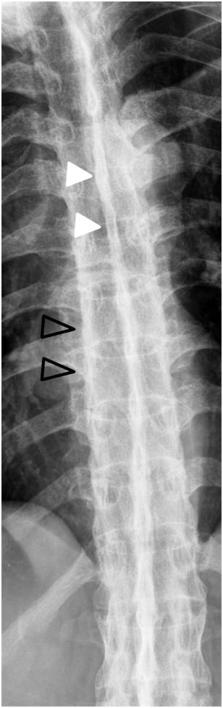
Fig 3. Antero posterior view of the thoracic and lumbar spine. Note the calcification of the interspinous ligaments secondary to enthesitis, with the classical “dagger” sign (arrow heads), stretching into the pelvis. The “trolley tracts” sign, can also be seen in the lower lumbar spine and thoracic spine (open arrows), lateral to the calcified interspinous ligaments, representing the calcified apophyseal joint capsules.

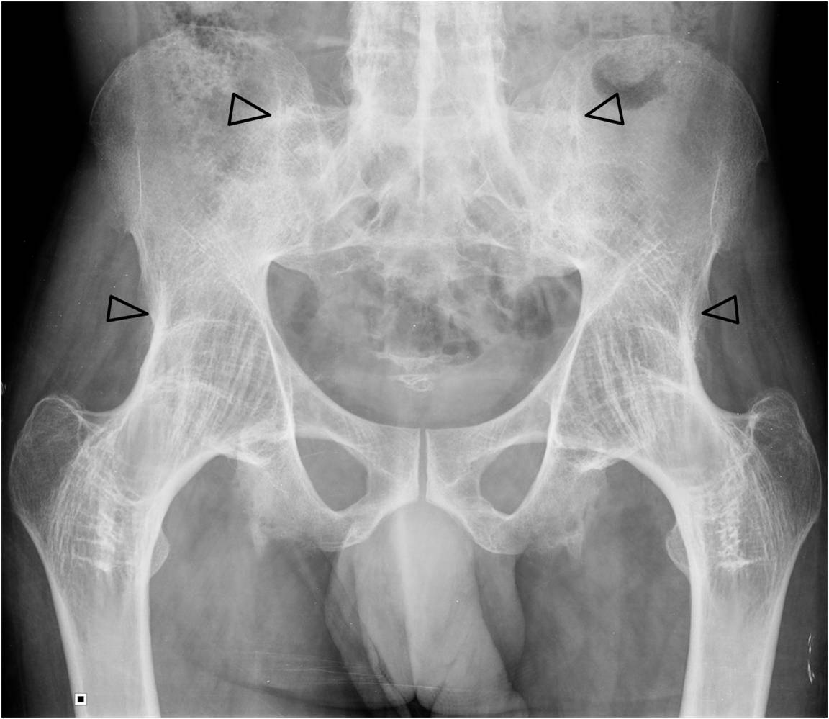
Fig 4. Antero-posterior view of the pelvis. The open arrowheads depict the marked ankylosis of the hips and sacro-iliac joints

