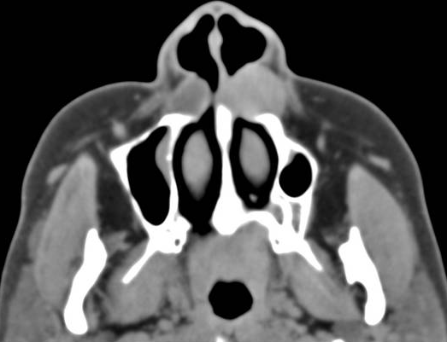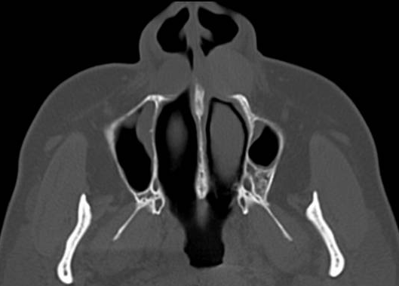

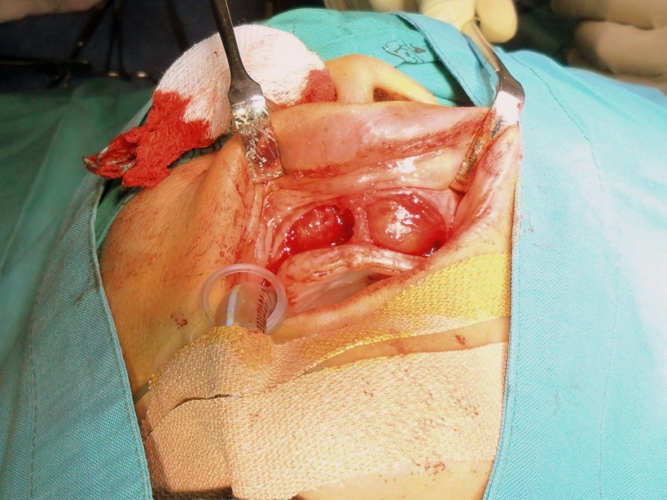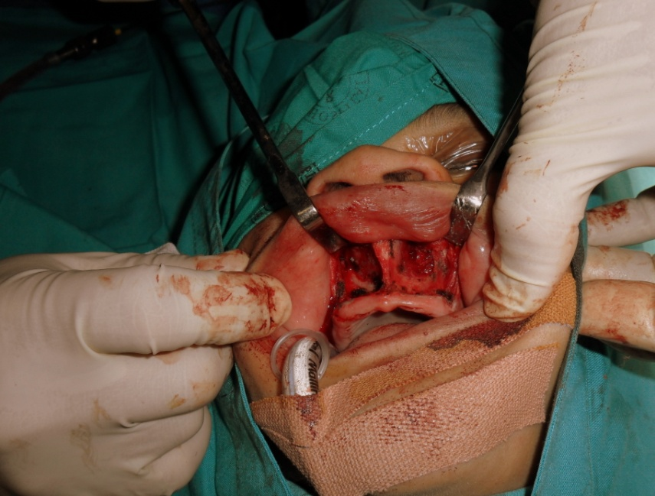

*Figure 1. Bilateral well demarcated ovoid lesions of soft tissue density anterior to the premaxilla.*

*Figure 2. Subtle smooth remodeling of the adjacent pre maxilla and no inferior turbinate involvement.*

*Figure 3. Bilateral soft tissue cysts visible via a sublabial incision.*

*Figure 4. Bony fossas visible after cyst excision: a result of remodeling.*